PYTHON – R

Binomial distribution

exactly
p = scipy.stats.binom.pmf(k=3, n=5, p=0.3)
p = dbinom(3, 5, p=0.3) #R
=BINOM.DIST(3, 5, 0.3, FALSE) #Excel
probability that you’ll have exactly 3 sucesses out of 5 trials if the probability of each success is 0.3

at most
p = scipy.stats.binom.cdf(k=3, n=5, p=0.3)
p = pbinom(3, 5, p=0.3) #R
probability that you’ll have 3 or less sucesses out of 5 trials if the probability of each success is 0.3

at least
p = 1 - scipy.stats.binom.cdf(k=2, n=5, p=0.3)
p = 1 - pbinom(2, 5, p=0.3) #R
probability that you’ll have 3 or more sucesses out of 5 trials if the probability of each success is 0.3

DESCRETE MATHEMATICS

Prime Number Generator
def IsPrime(n): #1 is omitted
assert int(n)==n, "Whole numbers only, please!"
if n==1: return None
for i in range(2,n):
if n%i==0: return False
else: return True

def PrimeNumbersGenerator(n):
assert int(n)==n, "Whole numbers only, please!"
for i in range(2, n+1):
if IsPrime(i):
yield i

ALGEBRA

Polynomial Equations

nd = numpy.roots([n,n,n]) n,n,n are the polynomial coefficients

import numpy
""" Find a root which is a positive whole number (if any) for the equation:
3x^2 + 4x + 1 = 96
3x^2 + 4x - 95 = 0
So the coefficients for the equation are: [3,4,-95]
"""
nd = numpy.roots([3,4,-95])
print(nd)

ndRes = numpy.logical_and(nd>0, nd%1==0)
print(ndRes)
n = nd[ numpy.logical_and(nd>0, nd%1==0) ][0]
print("The positive whole root of the equation is {}".format(int(n)))

import numpy
"""PROBLEM 1 - In what system is 7 represented as 111 ?
1x^2 + 1x^1 + 1x^0 = 7
x^2 + x + 1-7 = 0
x^2 + x + 6 = 0
The coefficients are: [1, 1, -6]
"""
nd = numpy.roots([1,1,-6])
print(nd) # The answer is 2

"""PROBLEM 2
The number 341 is written in an unknown system. We know that it equals 96 in base ten system.
In what system is 341 written?
3x^2 + 4x^1 + 1x^0 = 96
3x^2 + 4x + 1 - 96 = 0
3x^2 + 4x - 95 = 0
So the coefficients for our equation are: [3,4,-95]
"""
nd = numpy.roots([3,4,-95])
print(nd)
print("The answer is: base {}".format(int(nd[nd>0][0])))

find the roots a polynomial equasion
aRoots = np.roots(aCoefficients) # aRoots = x-axis-intercepts
aCoefficients = [-1, 2, 3, 1] if y = -1x^3 + 2x^2 + 3x + 1

find a polynomial equation (reverse of the above)
aCoefficients = np.polyfit(X, Y, deg=3)

"""
for example
y = -1x^3 + 2x^2 + 3x^1 + 4x^0
y = -1x^3 + 2x^2 + 3x + 4
e.g. y==5 then the equasion changes, i.e. the curve is shifted downwards in this case
5 = -1x^3 + 2x^2 + 3x + 4
-1x^3 + 2x^2 + 3x + 4 - 5 = 0
-1x^3 + 2x^2 + 3x - 1 = 0
so, the new equation reads:
y = -1x^3 + 2x^2 + 3x - 1
and its coefficients are: [-1, 2, 3, -1]
"""
import numpy as np; np.set_printoptions(linewidth=200, suppress=True)
aCoefficients = [-1, 2, 3, -1]
aRoots = np.roots(aCoefficients) # aRoots = x-axis-intercepts
print(aRoots)
#the reverse process - to find an equation for X and Y arrays
X = np.linspace(-2, 4, 31,endpoint=True)
#make the function
f = lambda x, c1, c2, c3, c4 : c1*x**3 + c2*x**2 + c3*x + c4 #y = -1x^3 + 2x^2 + 3x - 1
from functools import partial
f = partial(f, c1=aCoefficients[0], c2=aCoefficients[1], c3=aCoefficients[2], c4=aCoefficients[3])
f = np.vectorize(f)
Y = f(X)
print(X,Y)
aCoefficients = np.polyfit(X, Y, deg=3) # these coefficients are equal to the original ones
print(aCoefficients) #[-1. 2. 3. -1.]

TRIGANOMETRY

Exploring the sinusoid
$$y=a*\sin\left(p*x+h\right)+v$$

a = increases/decreases the amplitude
p = increases/decreases the period
h = moves the sinusoid horizontally
v = moves the sinusoid vertically

import numpy, matplotlib.pyplot, seaborn; numpy.set_printoptions(linewidth=150)

class C():
NumberOfPeriods = 2
NumberOfDataPoints = 300

sp = matplotlib.pyplot.subplots()[1]

"""Simple sinusoid"""
X = numpy.linspace(start=0, stop=2*numpy.pi*C.NumberOfPeriods, num=C.NumberOfDataPoints, dtype='f')
Y = numpy.sin(X)
sp.plot(X,Y, label="$y = sin(x)$")

"""linear increment of amplitude"""
YLinearIncrementOfAmplitude = (X/10+1) * numpy.sin(X)
sp.plot(X, YLinearIncrementOfAmplitude, label=r"linear increment of amplitude: $y = (\frac{x}{10}+1) * sin(x)$")

"""linear compression of period"""
YLinearIncrementOfPeriod = numpy.sin(X * (X/10+1))
sp.plot(X, YLinearIncrementOfPeriod, label = r"linear compression of period: $y = sin ( (\frac{x}{10}+1) * x )$")

"""combination of the two above"""
Y = (X/10+1) * numpy.sin(X * (X/10+1))
sp.plot(X, Y, color='grey', linestyle=":", label = "combination of the two above")

"""Configure the plot"""
sp.axhline(0, color='k', alpha=0.5)
sp.legend(fontsize=8)
matplotlib.pyplot.show()

CALCULUS

LINEAR ALGEBRA

Euclidean distance
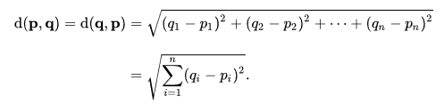
mx = t(matrix(c(1,2,3,4), nrow=2))
w = dist(mx)

v1 = c(1,2,3)
v2 = c(4,5,6)
d = sqrt(sum((v1-v2)**2)) #distance between two points in 3D: (1,2,3) and (4,5,6)

mx = matrix(rbind(v1,v2), nrow=2)
mx = matrix(dist(mx))

# 3 points in 5D
mx = matrix(1:15, nrow=3, byrow=TRUE)
w = dist(mx)

#test the distance between pint 1 and point 3
d = sqrt(sum((mx[1,] - mx[3,])**2))

w = dist(mx)

distance between two points aka vectors
v1 = c(1,2,3)
v2 = c(4,5,6)
d = sqrt(sum((v1-v2)**2)) #distance between two points in 3D: (1,2,3) and (4,5,6)

v1 = c(7, 1, 9, 1, 3)
v2 = c(4, 9, 1, 3, 1)
v3 = c(9, 1, 7, 2, 2)

#Eucledian distance
mx = matrix(rbind(v1,v2,v3), nrow = 3)
w = dist(mx)
print(w)

#correlation
mxCor = matrix(rep(0,9), nrow=3)
for (i in 1:3){
for (j in 1:3){
mxCor[i,j] = cor(mx[i,], mx[j,])
}
}
print(mxCor)

#graphical
plot(v1, col="red", type="l")
lines(v2, col="green")
lines(v3, col="blue")

def DotProduct(a1, a2): #dot product of two vectors
assert all(hasattr(e, "__iter__") for e in (a1,a2))\
and len(a1)==len(a2)\
and all(type(e) in (int, float) for a in (a1,a2) for e in list(a))
from operator import mul
return sum(mul(e1,e2) for e1,e2 in zip(a1,a2))

def VectorLength(a): #length of a vector from (0,0,...0)
assert hasattr(a, "__iter__") and all(type(e) in (int, float) for e in list(a))
return sum(e**2 for e in a)**0.5
return DotProduct(a, a)**0.5 #same

a1 = [1,2,3]
a2 = (4,5,6)

n = DotProduct(a1, a2)
print(n)

a = a1
n = VectorLength(a)
print(n)

Cosine Similarity

used in product recommendations (Item-Based Collaborative Filtering)

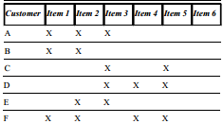
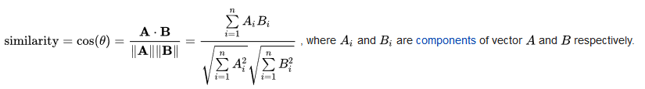

the cosine similarity is the $cos⁡(θ)$ between the two vectors. Its value is between 0 and 1
1 = prefect similarity (i.e. the angle is equal to 0 degrees)

#Cosine Similarity
import numpy as np, pandas as pd
np.set_printoptions(linewidth=200, precision=2)
pd.set_option('display.float_format', lambda x: '%.2f' % x)
from MyUtilities import print
# the columns are vectors i.e. we have six 9D vectors:
l = \
[[1,1,1,0,0,0],
[1,1,0,0,0,0],
[0,0,1,0,1,0],
[0,0,1,1,1,0],
[0,1,1,0,0,0],
[1,1,0,1,1,0],
[1,0,1,0,0,0],
[1,0,0,0,0,0],
[0,0,0,0,0,1]]
mx = np.array(l, dtype=np.uint8)
print(mx)
# cosine similarity between two vectors:
A = mx[:,0] # vector A
B = mx[:,1] # vector B
print(A,B)
CosineSimilarity_A_B = np.dot(A,B) / (np.sqrt(np.sum(A**2)) * np.sqrt(np.sum(B**2)))
print(CosineSimilarity_A_B)
# cosine similarity between all possible pairs of vectors:
mx = mx.T#[:4,:3]
mx[np.newaxis,:,:]
mx[:,np.newaxis,:]
mxDotProduct = np.sum(mx[np.newaxis,:,:] * mx[:,np.newaxis,:], axis=-1)
print(mxDotProduct)
a = np.sqrt(np.sum(mx**2, axis=1)) # a = array of vector magnitudes
mxMagnitudeProducts = a * a[:, np.newaxis]
print(mxMagnitudeProducts)
a2D_CosineSimilarities = mxDotProduct / mxMagnitudeProducts
print(a2D_CosineSimilarities)
l = ["v{}".format(i) for i in range(1, len(a2D_CosineSimilarities)+1)]
df = pd.DataFrame(a2D_CosineSimilarities, dtype=np.float32, index=l, columns=l)
print(df)

STATISTICS

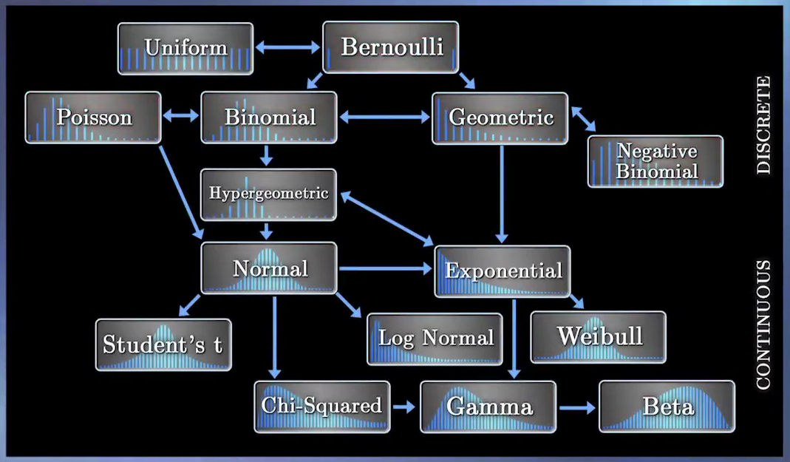
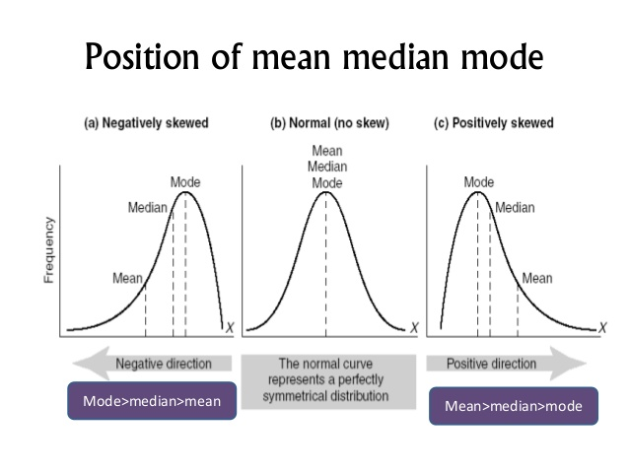

Binomial Distribution

# demo on how
# population proportion (which follows the binomilal distribution)
# is approximated by the normal density function

from statistics import mean
from statistics import pstdev
from math import sqrt
import scipy.stats, numpy
numpy.set_printoptions(precision=4, linewidth=300, suppress=True)

p = .3
n = 20
r = range(n+1)
aProbabilities = [scipy.stats.binom.pmf(k=k, n=n, p=p) for k in r]
print("probabilities:", aProbabilities, "\n")

# formula-driven mean, sd and CI
mu = n*p
print("formula-driven mean =", mu)

sigma = sqrt(n*p*(1-p))
print("formula-driven SD =", sigma)

SE = sqrt((p*(1-p))/n)
print("SE =", SE)

z = scipy.stats.norm.ppf(0.9 + (1-0.9)/2)
ME = SE*z
print("ME =", ME)

CI = (p-ME, p+ME)
print("90% CI =", CI)
print()

# experimental mean, sd and CI
i = 100000 # multiplier
nd = numpy.array(aProbabilities) * i

l = []; [l.extend([x]*round(k)) for x,k in zip(r, nd.tolist())]

mu = mean(l)
print("experimental mean =", mu, "(meaning on average you'll get {:0.2f} successes in {} trials)".format(mu, n))

sigma = pstdev(l)
print("experimantal SD =", sigma)

CI = l[round(i*0.05)]/n, l[round(i*0.95)]/n
ME = (CI[1]-CI[0])/2
SE = ME/sigma
print("experimental SE =", SE)
print("experimental ME =", ME)
print("experimental 90% confidence interval =", CI)

p = 0.3
n = 10

a = c()
for (i in 1:1000){
CurrentSample = sample(c(TRUE, FALSE), n, prob=c(0.3, 0.7), replace=TRUE)
iHowManySuccesses = sum(CurrentSample)
a = c(a, iHowManySuccesses)
}
# mu = mean number of successes in a sample of size n
MeanOfSuccesses = mean(a)
print(paste("experimental mu =", MeanOfSuccesses))
print(paste("theoretical mu =", n*p, "(short formula)"))

# sum of binomial probabilities
aProbabilities = dbinom(0:n, size=n, prob=p)
aProbabilities = aProbabilities * 0:n
Sum = sum(aProbabilities)
print(paste("theoretical mu =", Sum, "(long formula)"))

# sigma = SD of the success numbers in many samples of size n
sigma = sd(a)
print(paste("experimental SD =", sigma))
sigma = sqrt(n*p*(1-p))
print(paste("theoretical SD =", sigma))

# SE = SD of the actual probabilities of all possible sample of size n
SE_phat = sd(a/n)
print(paste("experimental SE =", SE_phat))
SE_phat = sqrt((p*(1-p))/n)
print(paste("theoretical SE =", SE_phat))

Normal approximation to the binomial distribution
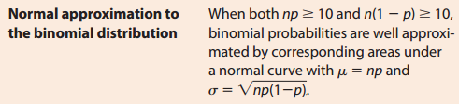
p = 0.3
n = 35

b = n*p>=10 & n*(1-p)>=10; print(paste("Approximateion to Normal distribution can be used:", b))

aProbabilities = dbinom(0:n, size=n, prob=p)
barplot(height=aProbabilities, names.arg=0:n, space=0, ylim=c(0, 0.16))

mu = n*p ; print(paste("mu =", mu))
sigma = sqrt(n*p*(1-p)) ; print(paste("sigma =", sigma))

curve(dnorm(x-0.25, mean=mu, sd=sigma), add=TRUE)

# Approximation to a Normal distribution
# what's the probability of X <= 7
P = pbinom(7, size=n, prob=p)
P = sum(dbinom(0:7, size=n, prob=p)) #same
print(paste("binomila probability =", P))

z = (7.5 - mu) / sigma # note that it is 7.5 and not 7 because ...
P = pnorm(z)
print(paste("normal approximation probability =", P))

Confidence Interval

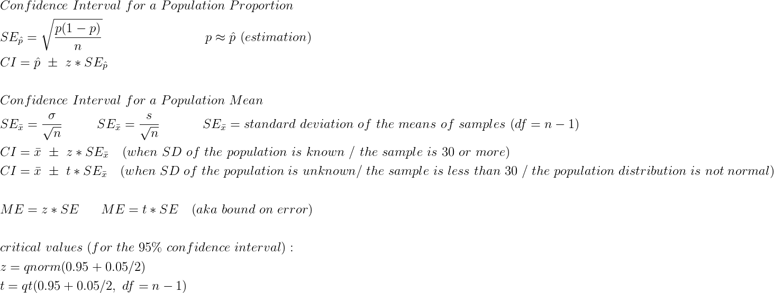

\begin{align*}
&Confidence\ Interval \ for\ a\ Population\ Proportion \\
&SE_{\hat{p}}=\sqrt{\frac{p(1-p)}{n}}\qquad \qquad \qquad \qquad p \approx \hat{p}\ (estimation)\\
&CI = \hat{p}\ \pm\ z*SE_{\hat{p}}\\
&\\
&Confidence\ Interval \ for\ a\ Population\ Mean\\
&SE_{\bar{x}}=\frac{\sigma}{\sqrt{n}}\ \ \ \ \ \ \ \ SE_{\bar{x}}=\frac{s}{\sqrt{n}}\ \ \ \ \ \ \ \ \ \ SE_{\bar{x}}= standard\ deviation\ of\ the\ means\ of\ samples\ (df=n-1)\\
&CI=\bar{x}\ \pm\ z*SE_{\bar{x}}\ \ \ (when\ SD\ of\ the\ population\ is\ known\ /\ the\ sample\ is\ 30\ or\ more)\\
&CI=\bar{x}\ \pm\ t*SE_{\bar{x}}\ \ \ {\small (when\ SD\ of\ the\ population\ is\ unknown /\ the\ sample\ is\ less\ than\ 30\ /\ the\ population\ distribution\ is\ not\ normal)}\\
&\\
&ME = z*SE \ \ \ \ \ ME=t*SE \ \ \ (aka\ bound\ on\ error)\\
&\\
&critical\ values\ (for\ the\ 95\%\ confidence\ interval):\\
&z=qnorm(0.95+0.05/2)\\
&t=qt(0.95+0.05/2, \ df=n-1)\\
\end{align*}

#Demo on drawing all possible samples(w/out replacement) from a population
#Demo on confidence intervals based on a single sample
import itertools, scipy.misc, sympy, random, statistics, math, scipy.stats

N=50; k=int(N*0.1)

i = scipy.misc.comb(N=N, k=k, repetition=False, exact=True)
print("number of possible combinations =", i)

fPropotion=0.5 #this is not probability!
A,B = sympy.symbols("A B")
d = sympy.solve([A/B-fPropotion, A+B-N])
A,B = [round(e) for e in (d[A],d[B])]
print(d, A,B)

fPropotion = A/B
p = A/(A+B)
print("proportion of A:B =",fPropotion, "\nprobability of A = {:.2%}".format(p))

lPopulation = [1]*A + [0]*B; random.shuffle(lPopulation)
g = itertools.combinations(lPopulation, k)

lProbabilities = []
for t in g: lProbabilities.append(sum(t)/k)
else: lProbabilities = sorted(lProbabilities)

fExperimentalProbability = statistics.mean(lProbabilities)
print("experimental probability (mu sub p hat) =", fExperimentalProbability)

#Draw a sample
aSample = random.sample(lPopulation, k) #sampling w/out repetition
n = len(aSample) # n=k
p_hat = sum(aSample)/n
print("p hat =", p_hat)

CI = 90#%
fAreaUnderTheCurve = CI/100 + (1-CI/100)/2
SE = math.sqrt((p_hat*(1-p_hat))/n)
z = scipy.stats.norm.ppf(fAreaUnderTheCurve)
t = scipy.stats.t.ppf(fAreaUnderTheCurve, df=n-1)
print(z,t)

CI_z = (p_hat - z*SE, p_hat + z*SE)
CI_t = (p_hat - t*SE, p_hat + t*SE)

print("CI (z distribution) =", CI_z)
print("CI (t distribution) =", CI_t)

#Check whether 90% of lProbabilities are actually between the lower and upper limits of the calculated CI
#90% means you have to cut off 5% from each side of the samples array (lProbabilities)
# i = len(lProbabilities)
iFivePercentOfTheSampleArray = int(i * 0.05)
#print(iFivePercentOfTheSampleArray)

lProbabilities[:iFivePercentOfTheSampleArray] = ()
lProbabilities[-iFivePercentOfTheSampleArray:] = ()
fLowerLimit,fUpperLimit = lProbabilities[::len(lProbabilities)-1]
print("these lower and upper limits", (fLowerLimit,fUpperLimit), "should correspond to the CI's:", CI_z, CI_t)

Distribution of z-scores of x̄’s
in other words: distribution of normalized (i.e. measured in standard deviations) means of samples

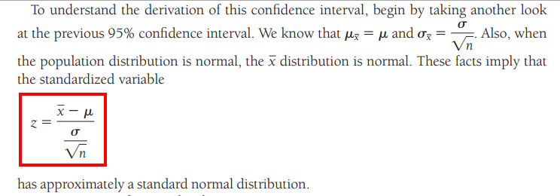
import numpy, statistics, random
from math import sqrt
import matplotlib.pyplot as mp

N = 10000
n = 30
mu = 10; sigma = 5

a = numpy.random.normal(mu, sigma, size=N).tolist()
mu = statistics.mean(a)
sigma = statistics.pstdev(a)

d = dict(s=".2f", approx=chr(8776))
print("population mean = {:{s}}".format(mu, **d)); print("population SD = {:{s}}".format(sigma, **d))

i = 1000 #how many simulations
x_bars = sorted(statistics.mean(random.sample(a, n)) for _ in range(i)) #sampling w/out replacement
mu_x_bars = statistics.mean(x_bars) ; print("mean of means (mu_x_bars) = {:{s}}".format(mu_x_bars, **d))
SE_x_bars = statistics.pstdev(x_bars) ; print("sampling SE (i.e. SD of the means of samples) = {:{s}}".format(SE_x_bars, **d), end="")
SE_x_bars = sigma / sqrt(n) ; print("\t\tformula-driven SE = {:{s}}".format(SE_x_bars, **d))
ZScores_of_x_bars = (numpy.array(x_bars) - mu) / SE_x_bars #this calculation is only possible in theory because you have to know the mean of the whole population, as well as its SD

mu_ZScores_of_x_bars = statistics.mean(ZScores_of_x_bars)
sigma_ZScores_of_x_bars = statistics.stdev(ZScores_of_x_bars)
print("mean and SD of the z-scores of x-bars: {:{s}}, {:{s}} (note that they indicate that this is the standard normal distribution with mu{approx}0 and sigma{approx}1)".format(mu_ZScores_of_x_bars, sigma_ZScores_of_x_bars, **d))

#histogram of the z-scores of the x-bars
sp = mp.subplots()[1]
sp.hist(ZScores_of_x_bars, bins=25)
sp.set_title("Distribution of z-scores of x̄’s")
mp.show()

import scipy.stats; from collections import namedtuple
def QQPlot(X, Plot=True): #aka normal probability plot
assert hasattr(X, "__iter__") and all(type(e) in (int,float) for e in numpy.array(X).tolist()), "Your array must be a vector of numbers!"
Y = sorted(X); iNumberOfDataPoints = len(X); iNumberOfIntegrals = iNumberOfDataPoints+1; fAreaOfEachIntegral = 1/iNumberOfIntegrals
lCumulativeAreas = [i*fAreaOfEachIntegral for i in range(1,iNumberOfIntegrals+1)]; lCumulativeAreas=lCumulativeAreas[:-1]
X = ZScores = [scipy.stats.norm.ppf(fArea) for fArea in lCumulativeAreas]

#add the dots to the plot
sp = mp.subplots()[1]; sp.plot(X, Y, "g.")

def _CorrelationCoefficient(X,Y):
XMean,YMean = [statistics.mean(a) for a in (X,Y)]
XSD,YSD = [statistics.stdev(a) for a in (X,Y)] #unbiased SD
nd2D = numpy.array([(numpy.array(a)-mu)/sd for a,mu,sd in zip((X,Y), (XMean,YMean), (XSD,YSD)) ])
nd = nd2D[0]*nd2D[1]
return float(nd.sum()/(len(X)-1)) #unbiased r

#calculate r, slope, intercept for the qq-line = regression line
r = _CorrelationCoefficient(X,Y)
m = (statistics.stdev(Y) / statistics.stdev(X)) * r # m = slope
(x,y) = statistics.mean(X), statistics.mean(Y)
y_intercept = y - m * x

#info for the function's "return"
func = namedtuple("qq", field_names=["correlation_coefficient_r", "slope", "y_intercept", "normal_scores"])
tNamed = func(r, m, y_intercept, ZScores)

#x,y coordinates to draw the (regression) line
X = numpy.array(sorted(X)[::len(X)-1]) #min and max values of the X array
Y = X * m + y_intercept

#add the regression line to the plot
sp.plot(X,Y, "k-", alpha=0.5)
sp.set_title("QQ Plot")
if Plot: mp.show()
return tNamed

tNamed = QQPlot(ZScores_of_x_bars) ; print(tNamed)

Distribution of t-scores of x̄’s
(small sample size, non-normal distribution, unknown population SD)
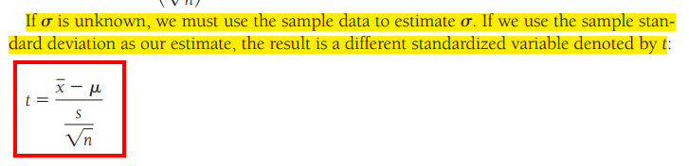
import numpy, statistics, random
from math import sqrt
import matplotlib.pyplot as mp
d = dict(s=".2f", approx=chr(8776))

N = 10000
n = 5 # n < 30
mu = 10; sigma = 3
a = numpy.random.normal(mu, sigma, size=N)

#trying to skew the distribution to the right
i=int(len(a)/1.5)
a[i::2] = abs(a[i::2]*0.3)**1.5 + a[i::2]
a = a.tolist()

#plot the whole population distribution
sp = mp.subplots()[1]
sp.hist(a, bins=50)
mp.show()

mu = statistics.mean(a)
sigma = statistics.pstdev(a)
print("population mean = {:{s}}".format(mu, **d))
print("population SD = {:{s}}".format(sigma, **d))

i = 1000 #how many simulations
x_bars_AND_s = [ tuple([statistics.mean(e), statistics.stdev(e)]) for e in (random.sample(a,n) for _ in range(i))] #list of (b_bar,s) for each sample
t_scores = [(x_bar-mu)/(s/sqrt(n)) for (x_bar,s) in x_bars_AND_s ]

#histogram of the t-scores of the x-bars
sp = mp.subplots()[1]
sp.hist(t_scores, bins=50)
sp.set_title("Distribution of t-scores of x̄’s")
mp.show()

import scipy.stats
def QQPlot(X, Plot=True): #aka normal probability plot
assert hasattr(X, "__iter__") and all(type(e) in (int,float) for e in numpy.array(X).tolist()), "Your array must be a vector of numbers!"
Y = sorted(X); iNumberOfDataPoints = len(X); iNumberOfIntegrals = iNumberOfDataPoints+1; fAreaOfEachIntegral = 1/iNumberOfIntegrals
lCumulativeAreas = [i*fAreaOfEachIntegral for i in range(1,iNumberOfIntegrals+1)]; lCumulativeAreas=lCumulativeAreas[:-1]
X = ZScores = [scipy.stats.norm.ppf(fArea) for fArea in lCumulativeAreas]

#add the dots to the plot
sp = mp.subplots()[1]; sp.plot(X, Y, "g.")

def _CorrelationCoefficient(X,Y):
nd2D = numpy.array([(numpy.array(a)-mu)/sd for a,mu,sd in zip((X,Y), [statistics.mean(a) for a in (X,Y)], [statistics.stdev(a) for a in (X,Y)]) ])
return float((nd2D[0]*nd2D[1]).sum()/(len(X)-1)) #unbiased r

#calculate r, slope, intercept for the qq-line = regression line
m = (statistics.stdev(Y) / statistics.stdev(X)) * _CorrelationCoefficient(X,Y) # m = slope r = _CorrelationCoefficient(X,Y)
(x,y) = statistics.mean(X), statistics.mean(Y)

#x,y coordinates to draw the (regression) line
X = numpy.array(sorted(X)[::len(X)-1]) #min and max values of the X array
Y = X * m + (y - m * x) #y_intercept = y - m * x

#add the regression line to the plot
sp.plot(X,Y, "k-", alpha=0.5)
sp.set_title("QQ Plot")
if Plot: mp.show()
return sp
QQPlot(t_scores)

Distribution of z-scores of p̂’s
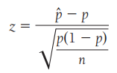
import random, numpy, statistics
import matplotlib.pyplot as mp
from math import sqrt

N = 100000
n = 100
p = round(random.random(), 2)
print("probability of success in the whole population =", p, "(hypothetical value)")

a = [1]*round(p*N) + [0]*round((1-p)*N); random.shuffle(a)

SE = sqrt((p*(1-p))/n)
print("theoretical SE = {}".format(round(SE,3)));print()

i = 1000 #number of simulations
ap = [ sum(random.sample(a,n))/n for _ in range(i) ] #p_hats of samples
mu_p_hat = statistics.mean(ap)
SE_experimental = statistics.stdev(ap)
print("mu_p_hat = {}".format(round(mu_p_hat,3)))
print("SE from resampling = {}".format(round(SE_experimental,3)))

NumberOfProbabilities = len(set(ap))
print("\nnumber of probability values in the sampling array =", NumberOfProbabilities, "(This means that we're dealing with discrete values - after all this is in effect Binomial distribution)")

z_scores = (numpy.array(ap) - p) / SE

sp = mp.subplots()[1]

lt = [(p, z_scores.tolist().count(p) ) for p in sorted(set(z_scores.tolist())) ]
sp.bar(*zip(*lt))
sp.set_xlabel("number of (standardized) probability values: {}".format(NumberOfProbabilities))
mp.show()

import scipy.stats
def QQPlot(X, Plot=True): #aka normal probability plot
assert hasattr(X, "__iter__") and all(type(e) in (int,float) for e in numpy.array(X).tolist()), "Your array must be a vector of numbers!"
Y = sorted(X); iNumberOfDataPoints = len(X); iNumberOfIntegrals = iNumberOfDataPoints+1; fAreaOfEachIntegral = 1/iNumberOfIntegrals
lCumulativeAreas = [i*fAreaOfEachIntegral for i in range(1,iNumberOfIntegrals+1)]; lCumulativeAreas=lCumulativeAreas[:-1]
X = ZScores = [scipy.stats.norm.ppf(fArea) for fArea in lCumulativeAreas]

#add the dots to the plot
sp = mp.subplots()[1]; sp.plot(X, Y, "g.")

def _CorrelationCoefficient(X,Y):
nd2D = numpy.array([(numpy.array(a)-mu)/sd for a,mu,sd in zip((X,Y), [statistics.mean(a) for a in (X,Y)], [statistics.stdev(a) for a in (X,Y)]) ])
return float((nd2D[0]*nd2D[1]).sum()/(len(X)-1)) #unbiased r

#calculate r, slope, intercept for the qq-line = regression line
m = (statistics.stdev(Y) / statistics.stdev(X)) * _CorrelationCoefficient(X,Y) # m = slope r = _CorrelationCoefficient(X,Y)
(x,y) = statistics.mean(X), statistics.mean(Y)

#x,y coordinates to draw the (regression) line
X = numpy.array(sorted(X)[::len(X)-1]) #min and max values of the X array
Y = X * m + (y - m * x) #y_intercept = y - m * x

#add the regression line to the plot
sp.plot(X,Y, "k-", alpha=0.5)
sp.set_title("QQ Plot"); sp.set_xlabel("explain why the dots are arranged in rows")
if Plot: mp.show()
return sp
QQPlot(z_scores)

Two-Sample t Confidence Interval for the Difference Between Two Population or Treatment means

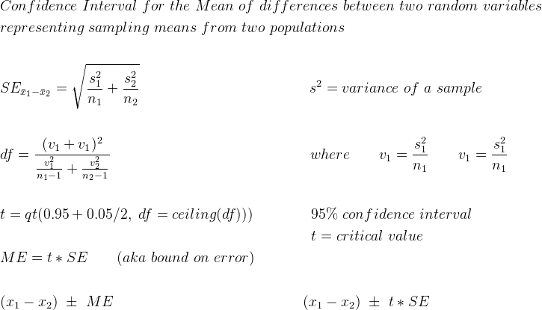

\begin{align*}
&Confidence\ Interval\ for\ the\ Mean\ of\ differences\ between\ two\ random\ variables\\
&representing\ sampling\ means\ from\ two\ populations\\
&\\
&SE_{\bar{x}_1-\bar{x}_2} = \sqrt{\frac{s^2_1}{n_1} + \frac{s^2_2}{n_2}}\qquad \qquad \qquad \qquad \quad \qquad \ \ s^2 = variance\ of\ a\ sample\\
&\\
&df = \frac{(v_1+v_1)^2}{\frac{v^2_1}{n_1-1} + \frac{v^2_2}{n_2-1}}\qquad \qquad \qquad \qquad \qquad \qquad \quad\ \ where\qquad v_1=\frac{s^2_1}{n_1}\qquad v_1=\frac{s^2_1}{n_1} \\
&\\
&t = qt(0.95 + 0.05/2,\ df=ceiling(df)))\qquad \qquad 95\%\ confidence\ interval\\
&\qquad \qquad \qquad \qquad \qquad \qquad \qquad \qquad \qquad \qquad \quad\ t=critical\ value\\
&ME = t*SE\qquad (aka\ bound\ on\ error)\\
&\\
&(x_1-x_2)\ \pm\ ME \qquad \qquad \qquad \qquad \qquad \qquad \quad (x_1-x_2)\ \pm\ t*SE\\
\end{align*}

my function that calculates Confidence Interval For Population Proportion
def ConfidenceIntervalForPopulationProportion(phat, n, confidence_interval=0.90, return_namedtuple=False):
from math import sqrt
import scipy.stats
SE = sqrt((phat*(1-phat))/n)
z = scipy.stats.norm.ppf(confidence_interval + (1-confidence_interval)/2)
ME = float(z*SE)
CI = (phat - ME, phat + ME)
if return_namedtuple:
from collections import namedtuple
func = namedtuple(typename="confidence_interval", field_names=["interval", "confidence_span", "standard_error", "z_critical_value", "margin_of_error"])
return func(CI, confidence_interval, SE, z, ME)
else: return CI

t = ConfidenceIntervalForPopulationProportion(phat=4/20, n=20)
print(t)

t = ConfidenceIntervalForPopulationProportion(phat=4/20, n=20, return_namedtuple=True)
print(t)

from math import sqrt
import scipy.stats

n = 1500
success = 820
p_hat = success / n
CI = 0.9
print("p-hat =", p_hat)

p_est = p_hat

SE = sqrt( (p_est*(1-p_est))/n )
print("SE =",SE)

z = scipy.stats.norm.ppf(CI + (1-CI)/2)
ME = z*SE
print("ME =", ME, "(percentage points)")

CI = (p_hat - ME, p_hat + ME)
print("CI =", CI, "(in percents i.e. probabilities)")

CI = CI[0]*n, CI[1]*n
print("CI =", CI, "(measured in the original units, in this case people supporting Obama)")

ME = (CI[1]-CI[0])/2
print("ME =", ME, "(measured in the original units, in this case people supporting Obama)")

Linear regression

My correlation coefficient r function
def CorrelationCoefficient(X,Y):
XMean,YMean = [statistics.mean(a) for a in (X,Y)]
XSD,YSD = [statistics.stdev(a) for a in (X,Y)] #unbiased SD
nd2D = numpy.array([(numpy.array(a)-mu)/sd for a,mu,sd in zip((X,Y), (XMean,YMean), (XSD,YSD)) ])
nd = nd2D[0]*nd2D[1]
return float(nd.sum()/(len(X)-1)) #unbiased r
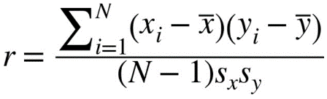
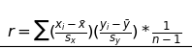

Finding the slope of a regression line
The formula for the slope, m, of the best-fitting line is
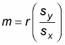
where r is the correlation between X and Y, and s_{x} and s_{y} are the standard deviations of the x-values and the y-values, respectively.

My QQ plot function
#My qq-plot function (with regression line and r,slope,y-intercept returned)
import numpy, scipy.stats, statistics
import matplotlib.pyplot as mp
from collections import namedtuple

def QQPlot(X, Plot=True): #aka normal probability plot
assert hasattr(X, "__iter__") and all(type(e) in (int,float) for e in numpy.array(X).tolist()), "Your array must be a vector of numbers!"
Y = sorted(X); iNumberOfDataPoints = len(X); iNumberOfIntegrals = iNumberOfDataPoints+1; fAreaOfEachIntegral = 1/iNumberOfIntegrals
lCumulativeAreas = [i*fAreaOfEachIntegral for i in range(1,iNumberOfIntegrals+1)]; lCumulativeAreas=lCumulativeAreas[:-1]
X = ZScores = [scipy.stats.norm.ppf(fArea) for fArea in lCumulativeAreas]

#add the dots to the plot
sp = mp.subplots()[1]; sp.plot(X, Y, "g.")

def _CorrelationCoefficient(X,Y):
XMean,YMean = [statistics.mean(a) for a in (X,Y)]
XSD,YSD = [statistics.stdev(a) for a in (X,Y)] #unbiased SD
nd2D = numpy.array([(numpy.array(a)-mu)/sd for a,mu,sd in zip((X,Y), (XMean,YMean), (XSD,YSD)) ])
nd = nd2D[0]*nd2D[1]
return float(nd.sum()/(len(X)-1)) #unbiased r

#calculate r, slope, intercept for the qq-line = regression line
r = _CorrelationCoefficient(X,Y)
m = (statistics.stdev(Y) / statistics.stdev(X)) * r # m = slope
(x,y) = statistics.mean(X), statistics.mean(Y)
y_intercept = y - m * x

#info for the function's "return"
func = namedtuple("qq", field_names=["correlation_coefficient_r", "slope", "y_intercept", "normal_scores"])
tNamed = func(r, m, y_intercept, ZScores)

#x,y coordinates to draw the (regression) line
X = numpy.array(sorted(X)[::len(X)-1]) #min and max values of the X array
Y = X * m + y_intercept

#add the regression line to the plot
sp.plot(X,Y, "k-", alpha=0.5)
sp.set_title("QQ Plot")
if Plot: mp.show()
return tNamed

def main():
X = numpy.random.normal(10, 2, size=100).tolist()
#X = numpy.arange(100).tolist() #range from 0 to 100
#X = numpy.random.uniform(size=100) #uniform
print(X[:10])

tNamed = QQPlot(X)
print(tNamed)

if __name__=="__main__":main()

Parametric Bootstrap

# parametric bootstrap
import numpy, statistics, random
from astropy.units import aPa
numpy.set_printoptions(precision=2, linewidth=150, suppress=True)

#########################################################################
#MY QQ PLOT FUNCTION
import numpy, scipy.stats, statistics
import matplotlib.pyplot as mp
from collections import namedtuple

def QQPlot(X, Plot=True): #aka normal probability plot
assert hasattr(X, "__iter__") and all(type(e) in (int,float) for e in numpy.array(X).tolist()), "Your array must be a vector of numbers!"
Y = sorted(X); iNumberOfDataPoints = len(X); iNumberOfIntegrals = iNumberOfDataPoints+1; fAreaOfEachIntegral = 1/iNumberOfIntegrals
lCumulativeAreas = [i*fAreaOfEachIntegral for i in range(1,iNumberOfIntegrals+1)]; lCumulativeAreas=lCumulativeAreas[:-1]
X = ZScores = [scipy.stats.norm.ppf(fArea) for fArea in lCumulativeAreas]

#add the dots to the plot
sp = mp.subplots()[1]; sp.plot(X, Y, "g.")

def _CorrelationCoefficient(X,Y):
XMean,YMean = [statistics.mean(a) for a in (X,Y)]
XSD,YSD = [statistics.stdev(a) for a in (X,Y)] #unbiased SD
nd2D = numpy.array([(numpy.array(a)-mu)/sd for a,mu,sd in zip((X,Y), (XMean,YMean), (XSD,YSD)) ])
nd = nd2D[0]*nd2D[1]
return float(nd.sum()/(len(X)-1)) #unbiased r

#calculate r, slope, intercept for the qq-line = regression line
r = _CorrelationCoefficient(X,Y)
m = (statistics.stdev(Y) / statistics.stdev(X)) * r # m = slope
(x,y) = statistics.mean(X), statistics.mean(Y)
y_intercept = y - m * x

#info for the function's "return"
func = namedtuple("qq", field_names=["correlation_coefficient_r", "slope", "y_intercept"])
tNamed = func(r, m, y_intercept)

#x,y coordinates to draw the (regression) line
X = numpy.array(sorted(X)[::len(X)-1]) #min and max values of the X array
Y = X * m + y_intercept

#add the regression line to the plot
sp.plot(X,Y, "k-", alpha=0.5)
sp.set_title("QQ Plot")
if Plot: mp.show()
return tNamed
#####################################################################################################################

N = 10000
n = 10
mu = 15
sd = 2.5
a = numpy.random.normal(mu, sd, size=N)
#print(a[:10])

mu = statistics.mean(a)
sd = statistics.stdev(a)
print("mean of the whole population =",mu, "\nSD of the whole population =", sd)

aSample = random.sample(a.tolist(), n)
#print(aSample)

mu = statistics.mean(aSample)
sd = statistics.stdev(aSample)
print("mean of the sample =", mu, "\nSD of the sample =", sd)

#check the normality from the qq plot
t = QQPlot(a); print("\ninfo about the whole population:\n",t)
t = QQPlot(aSample); print("\ninfo about the sample:\n",t)

#draw additional (virtual) data points from the normal distribution (assuming the sample shows normality)
aAdditional = numpy.random.normal(mu,sd, 30-n)
aParametricBootstrapSample = numpy.concatenate([aSample, aAdditional])

#info about the Parametric Bootstrap Sample
t = QQPlot(aParametricBootstrapSample); print("\ninfo about the whole population:\n",t)

fg,[sp1,sp2] = mp.subplots(nrows=1, ncols=2)
sp1.hist(a)
sp2.hist(aParametricBootstrapSample)
mp.show()

resampling with replacement = bootsrapping
#resampling with replacement (vs. confidence interval of the initial sample) to learn how much the statistic from the initial sample might be in error
import numpy, random, statistics, math
import scipy.stats
import matplotlib.pyplot as mp
numpy.set_printoptions(precision=2, linewidth=160, suppress=True)

N = 10000
n = 10
mu = 165
sd = 10
a = numpy.random.normal(mu,sd, size=N)
print("mean of the whole population = ", statistics.mean(a))
print("SD of the whole population =", statistics.pstdev(a)) ; print()

aSample = numpy.array(random.sample(a.tolist(), n))
print("mean of the original sample =", statistics.mean(aSample))
print("SD of the original sample =", statistics.stdev(aSample))

### Sample Size (optional) ###
DesiredMarginOfError = 3 # 2cm meaning 4cm #aka bound on error
CI = 90#%
z = scipy.stats.norm.ppf(CI/100+(1-CI/100)/2)
s = statistics.stdev(aSample)
n = int(round(((z*s)/DesiredMarginOfError)**2))
print("The sample size should be: {} (optional)".format(n)) ;print()
##########################################

n = 30
lMeansOfResampledSamples = []
for i in range(1000): #run the simulation 1000 times
aResampledSample = [random.choice(aSample) for _ in range(n)] #bootstrapping
fMeanOfTheCurrentResample = statistics.mean(aResampledSample)
lMeansOfResampledSamples.append(fMeanOfTheCurrentResample)

mu_x_bar = statistics.mean(lMeansOfResampledSamples) #mean of the sampling means
sigma_x_bar = statistics.stdev(lMeansOfResampledSamples) #SD of the sampling means distribution
fLowerBound = min(lMeansOfResampledSamples)
fUpperBound = max(lMeansOfResampledSamples)
fRange = fUpperBound-fLowerBound
print("mean of sampling means =",mu_x_bar)
print("SD of sampling means =", sigma_x_bar)
print("lower and upper bounds:",(fLowerBound,fUpperBound), "range =", fRange); print()

#lower and upper bound of the middle 90% of the sampling means
lMeansOfResampledSamples = sorted(lMeansOfResampledSamples)
i = int(round(0.05*len(lMeansOfResampledSamples)))
fLowerBound = lMeansOfResampledSamples[i]
fUpperBound = lMeansOfResampledSamples[-(i+1)]
print("lower and upper bounds (with the lower and upper 5% cut off):",(fLowerBound,fUpperBound), "(my calculation)")
fLowerBound = numpy.percentile(lMeansOfResampledSamples, q=5, interpolation="nearest")
fUpperBound = numpy.percentile(lMeansOfResampledSamples, q=95, interpolation="nearest")
print("lower and upper bounds (with the lower and upper 5% cut off):",(fLowerBound,fUpperBound), "(numpy nearest)")
fLowerBound = numpy.percentile(lMeansOfResampledSamples, q=5, interpolation="linear")
fUpperBound = numpy.percentile(lMeansOfResampledSamples, q=95, interpolation="linear")
print("lower and upper bounds (with the lower and upper 5% cut off):",(fLowerBound,fUpperBound), "(numpy linear)"); print()

#confidence interval (z distribution)
print("confidence interval = {}%".format(CI))
x_bar = statistics.mean(aSample)
z = scipy.stats.norm.ppf(CI/100+(1-CI/100)/2) #critical value
sigma = statistics.stdev(aSample) # sigma is approximately estimated to be equal to s (SD of the sample)
n = len(aSample) # = 10
CI_z = (x_bar - z*(sigma/math.sqrt(n)), x_bar + z*(sigma/math.sqrt(n)))
print("confidence interval (z distribution):", CI_z)

#confidence interval (t distribution)
t = scipy.stats.t.ppf(CI/100+(1-CI/100)/2, df=n-1)
s = statistics.stdev(aSample)
CI_t = (x_bar - t*(s/math.sqrt(n)), x_bar + t*(s/math.sqrt(n)))
print("confidence interval (t distribution):", CI_t)

#plot
fg,[sp1,sp2] = mp.subplots(nrows=1, ncols=2)
sp1.hist(a)
sp2.hist(lMeansOfResampledSamples)

sp1.set_title("population")
sp2.set_title("sampling means distribution")

mp.show()

Resampling/Bootstrap vs Formula-driven calculations

Resampling Procedure (Bootstrap) with population proportion
import random, statistics, scipy.stats, numpy
from math import sqrt
import matplotlib.pyplot as mp

n = 200
n1s = 72
n0s= 128
p = 72 / 200 #probability of success
#p = 0.1 #tweak the probability
#####################

a = [1]*round(p*n) + [0]*round((1-p)*n); random.shuffle(a)

lSuccessProportionsOfSamples = sorted( sum(random.choice(a) for _ in range(n)) / n for _ in range(1000) )

print("\nRESAMPLING/BOOTSTRAP RESULTS:")
mu_p_hat = statistics.mean(lSuccessProportionsOfSamples)
print("mean of sample means ({muphat}) = {:.4f}".format(mu_p_hat, muphat=b'\xce\xbc_p\xcc\x82'.decode("utf-8")))

#reasampling statistics details:
SE_p_hat = statistics.stdev(lSuccessProportionsOfSamples)
print("SE = {:.4f} (corresponds to the SD of the sampling means)".format(SE_p_hat))

CI = 90#%
LowerEnpoint,UpperEndpoint = [numpy.percentile(lSuccessProportionsOfSamples, q) for q in (5, 95)]
print("90% CI = ({:.4f}, {:.4f})".format(LowerEnpoint,UpperEndpoint))
print("ME = {:.4f}".format(UpperEndpoint - sum((LowerEnpoint,UpperEndpoint))/2))

#Formula-driven statistics details:
print("\nFORMULA DRIVEN RESULTS: (they are constant)")
p_hat = p
print("{} = {}".format(b'p\xcc\x82'.decode("utf-8"), p_hat)) #b'p\xcc\x82' == p-hat character

SE_p_hat = sqrt((p*(1-p))/n)
print("SE = {:.4f}".format(SE_p_hat))

Area = CI/100 + (1-CI/100)/2
z = scipy.stats.norm.ppf(Area) #critical value
ME = z*SE_p_hat
CI = (p_hat - ME, p_hat + ME)
print("90% CI = ({:.4f}, {:.4f})".format(*CI))
print("ME = {:.04}".format(ME))

sp = mp.subplots()[1]
sp.hist(lSuccessProportionsOfSamples, bins=20)
mp.show()
print("\nNote that the SE is largest when p is close to 0.5 and smallest when p is farthest from 0.5")

Resampling Procedure (Bootstrap) with population mean
#Resampling Procedure (Bootstrap)
import random, statistics, numpy, scipy.stats; import matplotlib.pyplot as mp; from math import sqrt

s = "13500 13750 13950 14950 13750 12950 16900 18600 21500 12950 20950 19950 19600 21500 22500 22000 22750 17950 16750 16950"
l = sorted(int(s) for s in s.split(" ") if s)
x_bar = statistics.mean(l)
print("mean of the original sample = {:.0f}".format(x_bar))
random.shuffle(l); n = len(l)

#bootstrap
lMeans = sorted((statistics.mean([random.choice(l) for _ in range(n)]) for _ in range(1000)), reverse=True)
mu_x_bar = statistics.mean(lMeans)
print("\nBootstrap results:")
print("mean of means (mu x bar) = {:.0f}".format(mu_x_bar))
sigma_x_bar = statistics.stdev(lMeans) # must be devided by n-1
print("SD of means = {:.0f} (this is in the Standard Error - calculated manually, in this case by bootstrapping)".format(sigma_x_bar))
LowerEndpoint = numpy.percentile(lMeans, 5)
UpperEndpoint = numpy.percentile(lMeans, 95)
CI = (LowerEndpoint, UpperEndpoint)
print("90% confidence interval: ({0:{form}}, {1:{form}})".format(*CI, form=".0f"))
print("mean (from the confidence level) = {0:.0f} \nmargin of error = {plusorminus} {1:.0f}".format(sum(CI)/2, UpperEndpoint-sum(CI)/2, plusorminus=chr(177)))

#theoretical (i.e. formula-driven) statistical results (using the original sample only):
Area = 0.9 + 0.1/2
z = scipy.stats.norm.ppf(Area) # critical value
t = scipy.stats.t.ppf(Area, df=n-1) # critical value
sigma = s = statistics.stdev(l) # assuming the population SD == SD of the sample
SE = s / sqrt(n) #standard error (same for z and t)
ME_z = SE*z # margin of error (z distribution)
ME_t = SE*t # margin of error (t distribution)
CI_z = (x_bar - ME_z, x_bar + ME_z)
CI_t = (x_bar - ME_t, x_bar + ME_t)
print("\nFormula-driven statistical results:")
print("mean of the sample = {:.0f}".format(x_bar))
print("SD of the sample = {:.0f}".format(s))
print("standard error = {:.0f} (this is the Standard Error calculated with the formula)".format(SE))
print("90% confidence interval (z) = ({0:{form}}, {1:{form}})".format(*CI_z, form=".0f"))
print("margin of error (z) = {plusorminus} {:.0f}".format(ME_z, plusorminus=chr(177)))
print("90% confidence interval (t) = ({0:{form}}, {1:{form}})".format(*CI_t, form=".0f"))
print("margin of error (t) = {plusorminus} {:.0f}".format(ME_t, plusorminus=chr(177)))

#plot
sp = mp.subplots()[1]; sp.hist(lMeans); mp.show()

Standard Deviation of the means of samples (generated for example by bootstrap) is the Standard Error.

Multiple Regression

3D Regression (linear and with transformation/interaction)
import numpy as np, matplotlib.pyplot as mp
from mpl_toolkits.mplot3d import Axes3D
import seaborn; seaborn.set()
np.random.seed(42)
n = 50
x0 = np.random.rand(n) * 10
x1 = np.sort(np.random.rand(n) * 15)
x2 = x0**2
x3 = x0 * x1
x4 = x1**2
y = 10 + 20*x0 + 30*x1 +40*x2 + 50*x3 + 60*x4 + np.random.randn(n)*1e+4
y = y[:,None]
X = np.array([x0,x1,x2,x3,x4]).T
#same as this:
from sklearn.preprocessing import PolynomialFeatures
ob = PolynomialFeatures(degree=2, include_bias=False)
X = np.array([x0, x1]).T
X = ob.fit_transform(X)
a = ob.get_feature_names()
print(a, X.shape)
from sklearn.linear_model import LinearRegression
md = LinearRegression()
md.fit(X, y)
nd = md.intercept_ ;print(nd)
nd = md.coef_ ;print(nd)
#plot
sp = mp.subplot(111, projection="3d")
sp.scatter(x0,x1,y, marker=".")
#plane
a = np.linspace(0, max([*x0,*x1]), 10)
X0,X1 = np.meshgrid(a,a)
X = np.array([X0.ravel(), X1.ravel()]).T
X = ob.fit_transform(X)
Y = md.predict(X)
Y.shape = X0.shape
sp.plot_surface(X0, X1, Y, cmap="gray", alpha=0.5)
#linear regression using x0 and x1 only
X = np.array([x0, x1]).T
print(X.shape)
md = LinearRegression()
md.fit(X, y)
nd = md.intercept_ ;print(nd)
nd = md.coef_ ;print(nd)
func = lambda x0, x1 : md.intercept_[0] + md.coef_[0,0]*x0 + md.coef_[0,1]*x1
func = np.vectorize(func)
#X0, X1 = np.meshgrid(a,a)
Y = func(X0, X1)
sp.plot_wireframe(X0, X1, Y, cmap="viridis", alpha=0.4)
[eval("sp.set_{0}label('{0}-axis')".format(s)) for s in "xyz"]
mp.show()

Mean and Variance of differences of sampling means from two populations

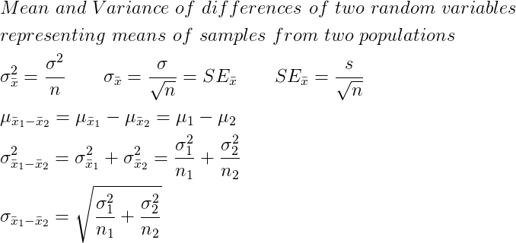

\begin{align*}
&Mean\ and\ Variance\ of\ differences\ of\ two\ random\ variables\\
&representing\ means\ of\ samples\ from\ two\ populations\\
&\sigma^2_{\bar{x}} = \frac{\sigma^2}{n} \qquad \sigma_{\bar{x}}=\frac{\sigma}{\sqrt{n}} = SE_{\bar{x}} \qquad SE_{\bar{x}} =\frac{s}{\sqrt{n}}\\
&\mu_{\bar{x}_1-\bar{x}_2} = \mu_{\bar{x}_1} - \mu_{\bar{x}_2} = \mu_1 - \mu_2 \\
&\sigma^2_{\bar{x}_1-\bar{x}_2}=\sigma^2_{\bar{x}_1} + \sigma^2_{\bar{x}_2} = \frac{\sigma^2_1}{n_1} + \frac{\sigma^2_2}{n_2}\\
&\sigma_{\bar{x}_1-\bar{x}_2} = \sqrt{\frac{\sigma^2_1}{n_1} + \frac{\sigma^2_2}{n_2}}\\
\end{align*}

proof of the sum of variances formula
import itertools, numpy, statistics

a = range(1,11)
N = 10
n = 3
a1 = numpy.random.normal(0, 2, size=N)
a2 = numpy.random.normal(0, 3, size=N)

fVarianceOfPopulation1 = statistics.pvariance(a1)
fVarianceOfPopulation2 = statistics.pvariance(a2)

print("variance of population 1 =", fVarianceOfPopulation1, "\t mean of population 1 =", statistics.mean(a1))
print("variance of population 2 =", fVarianceOfPopulation2, "\t mean of population 2 =", statistics.mean(a2))

print("formula-driven variance of sampling means from population 1 =", fVarianceOfPopulation1 / n)
print("formula-driven variance of sampling means from population 2 =", fVarianceOfPopulation2 / n)

g1 = itertools.combinations(a1, n)
g2 = itertools.combinations(a2, n)

aMeans1 = [statistics.mean(t) for t in g1]
aMeans2 = [statistics.mean(t) for t in g2]

fVarianceOfSamplingMeans1 = statistics.pvariance(aMeans1) #df = n-0 because all samples are there i.e. all possible combinations (?)
fVarianceOfSamplingMeans2 = statistics.pvariance(aMeans2)

print("real variance of sampling means from population 1 =\t", fVarianceOfSamplingMeans1)
print("real variance of sampling means from population 2 =\t", fVarianceOfSamplingMeans2)
fVarianceOfDifferencesOfMeansFormula1 = fVarianceOfSamplingMeans1 + fVarianceOfSamplingMeans2
print("formula-driven variance of differences of sampling means =", fVarianceOfDifferencesOfMeansFormula1, "(sum of the two variances above)")
fVarianceOfDifferencesOfMeansFormula2 = fVarianceOfPopulation1/n + fVarianceOfPopulation2/n
print("formula-driven variance of differences of sampling means =", fVarianceOfDifferencesOfMeansFormula2, "(idky it differs from the results below and above)")

#exhaustive array of differences of sampling means from two populations
aExhaustiveDifferenceOfMeans = []
[aExhaustiveDifferenceOfMeans.append(f1-f2) for f1 in aMeans1 for f2 in aMeans2]
print("real variance of differences of sampling means =", statistics.pvariance(aExhaustiveDifferenceOfMeans))

import itertools, numpy
from statistics import mean, stdev, variance, pvariance

N = 10
n = 3

a = numpy.random.normal(5, 2, size=N)
mu = mean(a)
print("real mean of the whole population =", mu)

g = itertools.combinations(a, n)

mu_x_bars = mean(mean(eSample) for eSample in g)
print("the mean of sampling means =", mu_x_bars)
print("CONCLUSION: the mean of means of all possible samples from a population is equal to the (true) mean of that population.")
print()####################

sigma2 = variance(a)
print("variance of the whole population =", sigma2)

g = itertools.combinations(a, n)
sigma2_x_bars = pvariance([mean(eSample) for eSample in g])
print("real variance of means of all possible samples from the population = ", sigma2_x_bars)
print("formula-driven variance of the means of samples from the population =", sigma2 / n)
print("IDKY the above variances differ")

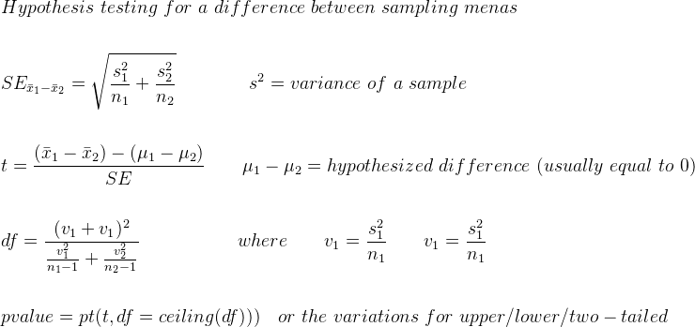

\begin{align*}
&Hypothesis\ testing\ for\ a\ difference\ between\ sampling\ menas\\
&\\
&SE_{\bar{x}_1-\bar{x}_2} = \sqrt{\frac{s^2_1}{n_1} + \frac{s^2_2}{n_2}}\qquad \qquad s^2 = variance\ of\ a\ sample\\
&\\
&t = \frac{(\bar{x}_1-\bar{x}_2) - (\mu_1-\mu_2)}{SE}\qquad \mu_1-\mu_2 = hypothesized\ difference\ ( usually\ equal\ to\ 0)\\
&\\
&df = \frac{(v_1+v_1)^2}{\frac{v^2_1}{n_1-1} + \frac{v^2_2}{n_2-1}}\qquad \qquad \quad\ where\qquad v_1=\frac{s^2_1}{n_1}\qquad v_1=\frac{s^2_1}{n_1} \\
&\\
&pvalue = pt(t, df=ceiling(df)))\quad or\ the\ variations\ for\ upper/lower/two-tailed\\
\end{align*}

proof of: sum of sampling variances of differences of means
import numpy, random
from statistics import variance, pvariance, mean
# population 1
i = 1000 # number of trials
N = 10000
n1 = 20
mu1=75.5
sigma1=3

Population1 = numpy.random.normal(mu1, sigma1, size=N).tolist()

N = 20000
n2 = 30
mu2 = 250.75
sigma2=5

Population2 = numpy.random.normal(mu2, sigma2, size=N).tolist()

print("true variance of population 1 =", pvariance(Population1))
print("true variance of population 2 =", pvariance(Population2))
print()
print("formula-based variance of means of samples of size {} taken from population 1 = {}".format(n1, pvariance(Population1)/n1))
print("formula-based variance of means of samples of size {} taken from population 2 = {}".format(n2, pvariance(Population2)/n2))

MeansOfSamplesFromPopulation1 = [ mean(random.sample(Population1, n1)) for _ in range(i) ]
MeansOfSamplesFromPopulation2 = [ mean(random.sample(Population2, n2)) for _ in range(i) ]

VarianceOfMeansOfSamplesFromPopulation1 = variance(MeansOfSamplesFromPopulation1) # df=n-1 because not all possible samples are used here, but only a portion of all possible samples
VarianceOfMeansOfSamplesFromPopulation2 = variance(MeansOfSamplesFromPopulation2)
print("sampling-based variance of means of samples of size {} taken from population 1 = {}".format(n1, VarianceOfMeansOfSamplesFromPopulation1))
print("sampling-based variance of means of samples of size {} taken from population 2 = {}".format(n2, VarianceOfMeansOfSamplesFromPopulation2))

print()
print("formula-based true_variance1 + true_variance2 =", pvariance(Population1)/n1 + pvariance(Population2)/n2)
print("sampling-based variance1 + variance2 =", VarianceOfMeansOfSamplesFromPopulation1+VarianceOfMeansOfSamplesFromPopulation2)
DifferencesOfMeans = numpy.array(MeansOfSamplesFromPopulation1) - numpy.array(MeansOfSamplesFromPopulation2)
VarianceOfDifferences = variance(DifferencesOfMeans)
print("sampling-based variance of differences =", VarianceOfDifferences)

Hypothesis testing

for population proportion:
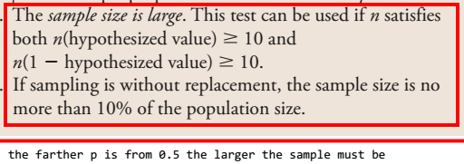
nSampleSizeMustBe = ceiling(max(10/p_hyp, 10/(1-p_hyp)))

Hypothesis Test for a Population Proportion
import random
from math import ceil, sqrt
import scipy.stats

N = 10000
p_real = 0.5
print("the real p =", p_real)
a = [1]*round(p_real*N) + [0]*round((1-p_real)*N) ; random.shuffle(a)

p_hypothesized = 0.5
print("hypothesized p =", p_hypothesized)

n = ceil(max( 10/p_hypothesized, 10/(1-p_hypothesized) ))
print("sample size must be at least:", n, "(note that the farther p is from 0.5 the larger the sample must be)")
assert N*0.1>n, "The sample must not be more than 10% of the population (because the sampling will be performed without replacement)"

aSample = random.sample(a,n)
p_hat = sum(aSample)/n
print("{phat} = {}".format(p_hat, phat=b'p\xcc\x82'.decode("utf-8")))
print("null hypothesis: p = {}".format(p_hypothesized))
print("alternative hypothesis: p {notequal} {}".format(p_hypothesized, notequal=chr(8800)))

SE = SD = sqrt( (p_hypothesized*(1-p_hypothesized))/n )
z = (p_hat - p_hypothesized) / SE
print("test statistic z = {:.3f}".format(z))

p_value = (1-scipy.stats.norm.cdf(z))*2 if z > 0 else scipy.stats.norm.cdf(z)*2
print("p-value = {0:.2f} ({0:.0%} probability that the given sample is not equal to the hypothesized value due to sampling variability)".format(p_value))

example of hypothesis testing with R
rm(list=ls())
n=1000
p_hyp = 0.5
p = p_hyp
p_hat=540/n
alpha=0.01

#test the sample size
nSampleSizeMustBe = ceiling(max(10/p_hyp, 10/(1-p_hyp)))
if (n<nSampleSizeMustBe){print(paste("Sample size must be at least",nSampleSizeMustBe))} else {print("Sample size is ok.")}

#Hypothesis testing
SE=sqrt((p*(1-p))/n )
z = (p_hat - p_hyp) / SE
p_value = 1-pnorm(z)
b = p_value < alpha #reject the null hypothesis?
print(paste("reject the null hypothesis?:",b))
print(paste(c("z","p-value"), "=", c(z,p_value)))

#confidence interval for p
CI = 95#%
Area = CI/100 + (1-CI/100)/2
z = qnorm(Area)
CI = c(p_hat - z*SE, p_hat + z*SE)
print("confidence interval for p:");print(CI)

example of hypothesis testing with Python
from math import ceil, sqrt
from scipy.stats import norm
pnorm = norm.cdf
qnorm = norm.ppf

n = 1000
p_hat = 210/n # =0.21
p_hyp = 0.2 # p hypothesized
p_real = None
alpha = 0.01

#formulate the hypothesis
print("H{subo}: p = {}".format(p_hyp, subo=chr(8338)))
print("H{suba}: p > {}\n".format(p_hyp, suba=chr(8336)))

#sample size test
nSampleSizeMustBe = ceil(max(10/p_hyp, 10/(1-p_hyp)))
print("sample size must be at leas:", nSampleSizeMustBe)

#hypothesis test
SE = sqrt( (p_hyp * (1-p_hyp))/n )
print("standard deviation of the probabilities of samples = {:.3f} (provided the null hypothesis is true)".format(SE))

z = (p_hat - p_hyp) / SE
print("test statistic z = {:.3f}".format(z))

p_value = 1-pnorm(z)
print("P-value = {:.3f}".format(p_value))

b = p_value < alpha
print("reject the null hypothesis?:","Yes" if b else "No");print()

#confidence interval
CI = 90#%
print("{}% CONFIDENCE INTERVAL".format(CI))
Area = CI/100 + (1-CI/100)/2

SE = sqrt( (p_hat*(1-p_hat))/n )
print("standard error = {:.3f}".format(SE))

z = qnorm(Area)
print("critical value = {:.2f}".format(z))

ME = z*SE
print("margin of error = {:.3f}".format(ME))

CI = (p_hat - ME, p_hat + ME)
print("confidence interval:", "({:{form}}, {:{form}})".format(*[round(e,3) for e in CI], form=".3f"))

pnorm = scipy.stats.norm.cdf
qnorm = scipy.stats.norm.ppf

Formula
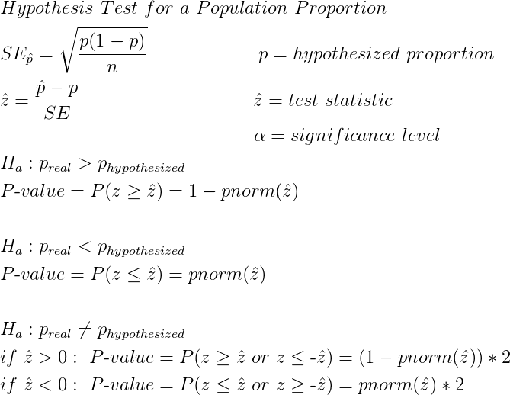
\begin{align*}
&Hypothesis\ Test\ for\ a\ Population\ Proportion \\
&SE_{\hat{p}}=\sqrt{\frac{p(1-p)}{n}}\ \ \ \ \ \ \ \ \ \ \ \ \ \ \ \ \ \ p=hypothesized\ proportion\\
&\hat{z}=\frac{\hat{p}-p}{SE}\qquad\qquad\qquad\qquad\quad\ \hat{z}=test\ statistic\\
&\qquad \qquad \qquad \qquad \qquad \qquad \quad\ \ \alpha=significance\ level\\
&H_a: p_{real}>p_{hypothesized}\\
&P\mbox{-}value=P(z\geq \hat{z})=1-pnorm(\hat{z})\\
&\\
&H_a: p_{real}<p_{hypothesized}\\
&P\mbox{-}value=P(z\leq \hat{z})=pnorm(\hat{z})\\
&\\
&H_a: p_{real}\neq p_{hypothesized}\\
&if\ \hat{z}>0 :\ P\mbox{-}value=P(z\geq \hat{z}\ or\ z\leq \mbox{-}\hat{z})=(1-pnorm(\hat{z}))*2\\
&if\ \hat{z}<0 :\ P\mbox{-}value=P(z\leq \hat{z}\ or\ z\geq \mbox{-}\hat{z})=pnorm(\hat{z})*2\\
\end{align*}

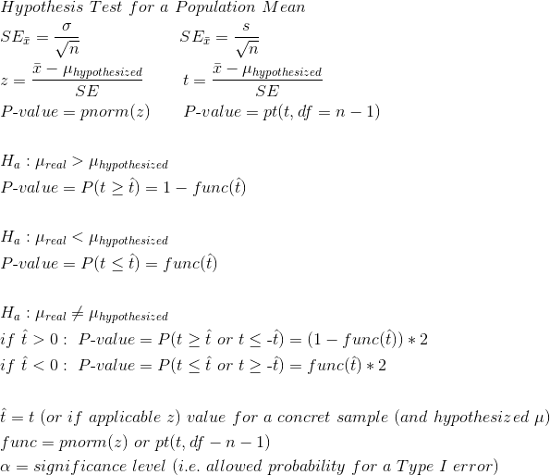

\begin{align*}

&Hypothesis\ Test\ for\ a\ Population\ Mean \\
&SE_{\bar{x}}=\frac{\sigma}{\sqrt{n}} \qquad \qquad \qquad SE_{\bar{x}}=\frac{s}{\sqrt{n}}\\
&z = \frac{\bar{x}-\mu_{hypothesized}}{SE} \qquad \ t = \frac{\bar{x}-\mu_{hypothesized}}{SE}\\
&P\mbox{-}value=pnorm(z)\qquad P\mbox{-}value=pt(t, df=n-1)\\
&\\
&H_a: \mu_{real}>\mu_{hypothesized}\\
&P\mbox{-}value=P(t\geq \hat{t})=1-func(\hat{t})\\
&\\
&H_a: \mu_{real}<\mu_{hypothesized}\\
&P\mbox{-}value=P(t\leq \hat{t})=func(\hat{t})\\
&\\
&H_a: \mu_{real}\neq \mu_{hypothesized}\\
&if\ \hat{t}>0 :\ P\mbox{-}value=P(t\geq \hat{t}\ or\ t\leq \mbox{-}\hat{t})=(1-func(\hat{t}))*2\\
&if\ \hat{t}<0 :\ P\mbox{-}value=P(t\leq \hat{t}\ or\ t\geq \mbox{-}\hat{t})=func(\hat{t})*2\\

&\\&\hat{t} = t\ (or\ if\ applicable\ z)\ value\ for \ a\ concret\ sample\ (and\ hypothesized \ \mu)\\
&func = pnorm(z)\ or\ pt(t, df-n-1)\\
&\alpha=significance\ level\ (i.e.\ allowed\ probability\ for\ a\ Type\ I\ error)\\
\end{align*}

My Hypothesis Test functions
def PopulationProportionHypothesisTest(p_hypothesized, p_hat, n, Ha="neq", alpha=0.01):
from math import sqrt, ceil; from collections import namedtuple
from inspect import stack
from scipy.stats import norm
pnorm = norm.cdf

phat, p = p_hat, p_hypothesized
if type(Ha) is str and (Ha.lower() in ("!=","<>","~=",chr(8800)) or Ha[0].lower()=="n"): Ha="!"
else:
if type(Ha) is not str or Ha not in ("<",">"): raise ValueError("H{suba} must be <, > or {}".format(chr(8800), suba=chr(8336)))
assert all(type(e) is float and e<1 and e>0 for e in (phat, p, alpha)), "wrong p value(s)!"
assert type(n) is int, "n must be an integer!"
assert phat != p, "p_hat and p_hypothesized must not be equal!"
assert n >= ceil(max(10/p, 10/(1-p))), "Sample size must be at least {}".format(ceil(max(10/p, 10/(1-p))))

SE = sqrt((p * (1-p))/n)
z = (phat - p) / SE

if Ha==">": p_value = 1-pnorm(z)
elif Ha=="<": p_value = pnorm(z)
elif Ha=="!" and z>0: p_value = (1-pnorm(z))*2
elif Ha=="!" and z<0: p_value = pnorm(z)*2
else: raise Exception("unforeseen error")

func = namedtuple(typename=stack()[0].function, field_names=["test_statistic_z", "p_value", "reject_null_hypothesis"])
return func(z, p_value, p_value<alpha)

def PopulationMeanHypothesisTest(mu_hypothesized, sample=None, x_bar=None, s=None, n=None, Ha="neq", alpha=0.01):
from math import sqrt; from collections import namedtuple
from inspect import stack
from scipy.stats import t
pt = t.cdf
x,mu,a = x_bar, mu_hypothesized, sample

assert a or (x_bar and s and n), "You must provide either a sample OR values for sample mean, SD and size!"
if a:
assert hasattr(a, "__iter__"), "sample msut be an array!"
from statistics import mean, stdev as std
x, s, n = mean(a), std(a), len(a)

if type(Ha) is str and (Ha.lower() in ("!=","<>","~=",chr(8800)) or Ha[0].lower()=="n"): Ha="!"
else:
if type(Ha) is not str or Ha not in ("<",">"): raise ValueError("H{suba} must be <, > or {}".format(chr(8800), suba=chr(8336)))
assert all(type(e) in (int, float) for e in (x, mu, s, alpha)), "wrong value(s)!"
assert type(n) is int, "n must be an integer!"
assert x != mu, "x_bar and mu_hypothesized must not be equal!"

SE = s / sqrt(n)
t = (x - mu) / SE

if Ha==">": p_value = 1-pt(t, df=n-1)
elif Ha=="<": p_value = pt(t, df=n-1)
elif Ha=="!" and t>0: p_value = (1-pt(t, df=n-1))*2
elif Ha=="!" and t<0: p_value = pt(t, df=n-1)*2
else: raise Exception("unforeseen error")

func = namedtuple(typename=stack()[0].function, field_names=["test_statistic_t", "p_value", "reject_null_hypothesis"])
return func(t, p_value, p_value<alpha)

def main():

t = PopulationProportionHypothesisTest(p_hat=0.61, p_hypothesized=0.6, n=400, Ha="<>")
print(t)

t = PopulationMeanHypothesisTest(mu_hypothesized=4.09, x_bar=2.6, s=1.2, n=132, Ha="<")
print(t)

a = [108, 112, 117, 130, 111, 131, 113, 113, 105, 128]
t = PopulationMeanHypothesisTest(mu_hypothesized=120, sample=a, Ha="<", alpha=0.05)
print(t)

a = [69, 65, 72, 73, 59, 55, 39, 52, 67, 57, 56, 50, 70, 47, 56, 45, 70, 64, 67, 53]
t = PopulationMeanHypothesisTest(mu_hypothesized=45, sample=a, Ha=">", alpha=0.05)
print(t)

t = PopulationMeanHypothesisTest(mu_hypothesized=10, x_bar=9.15, s=7.60, n=2000, Ha="<", alpha=0.01)
print(t)

t = PopulationMeanHypothesisTest(mu_hypothesized=12.5, x_bar=12.7, s=5, n=1000, Ha=">", alpha=0.05)
print(t)
t = PopulationMeanHypothesisTest(mu_hypothesized=12.5, x_bar=12.7, s=2, n=1000, Ha=">", alpha=0.05)
print(t)

a = [255, 244, 239, 242, 265, 245, 259, 248, 225, 226, 251, 233]
t = PopulationMeanHypothesisTest(mu_hypothesized=240, sample=a, Ha="<>")
print(t)

if __name__=="__main__":main()

Population Mean Hypothesis Testing

example with R
n = 50
mu_hyp = 48722
x_bar = 49850
s = 3300
alpha= 0.05
########################

#population mean hypothesis test
SE = s / sqrt(n)
print(SE)

t = (x_bar - mu_hyp) / SE
print(t)

p_value = pt(t, df=n-1, lower.tail = F) #upper-tailed test
print(p_value)

b = p_value < alpha
print(paste("reject Ho?",b))

#confidence interval
CI = 95#%
Area = CI/100 + (1-CI/100)/2
t = qt(Area, df=n-1)
ME = t*SE
CI = c(x_bar-ME, x_bar+ME)
print(CI)

Two sample hypothesis tests

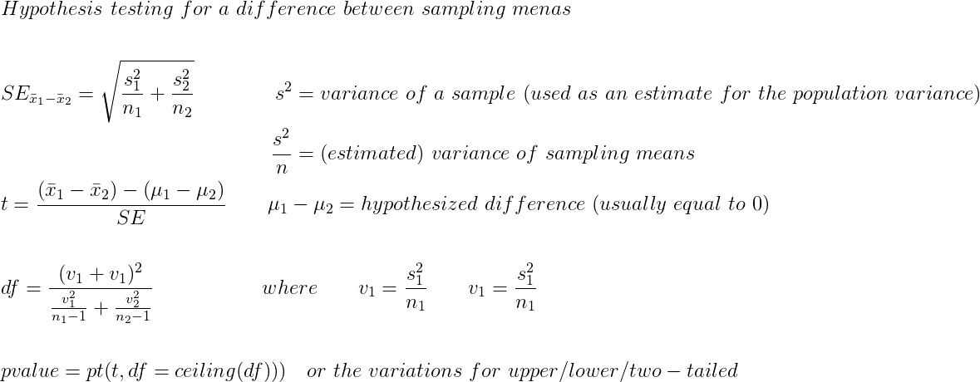
\begin{align*}
&Hypothesis\ testing\ for\ a\ difference\ between\ sampling\ menas\\
&\\
&SE_{\bar{x}_1-\bar{x}_2} = \sqrt{\frac{s^2_1}{n_1} + \frac{s^2_2}{n_2}}\qquad \qquad s^2 = variance\ of\ a\ sample\ (used\ as\ an\ estimate\ for\ the\ population\ variance)\\
&\qquad \qquad \qquad \qquad \qquad \qquad \quad \ \frac{s^2}{n}=(estimated)\ variance\ of\ sampling\ means\\
&t = \frac{(\bar{x}_1-\bar{x}_2) - (\mu_1-\mu_2)}{SE}\qquad \mu_1-\mu_2 = hypothesized\ difference\ ( usually\ equal\ to\ 0)\\
&\\
&df = \frac{(v_1+v_1)^2}{\frac{v^2_1}{n_1-1} + \frac{v^2_2}{n_2-1}}\qquad \qquad \quad\ where\qquad v_1=\frac{s^2_1}{n_1}\qquad v_1=\frac{s^2_1}{n_1} \\
&\\
&pvalue = pt(t, df=ceiling(df)))\quad or\ the\ variations\ for\ upper/lower/two-tailed\\
\end{align*}

example of a two sample hypothesis test in R
#male
n1 = 145
x1 = 85.2 #x-bar
s1 = 50
v1 = s1**2

#femaile
n2=141
x2 = 113.7
s2 = 75 #estimated population SD - estimated from the SD of the sample
v2 = s2**2 #sample variance

alpha = 0.05

SE = sqrt(v1/n1 + v2/n2)
print(paste("SE =", round(SE,3)))

t = (x1 - x2) / SE
print(paste("t =", round(t, 3)))

df = ceiling( (v1+v2)**2 / ( (v1^2) / (n1-1) + (v2^2) / (n2-1)))
print(paste("degrees of freedom = ", df))

pvalue = pt(t, df=df) * 2 #because two-tailed test
print(paste("pvalue =", pvalue))

b = pvalue < alpha
print(paste("reject null hypothesis:", b))

example of a two sample hypothesis test and confidence interval
a1 = as.numeric(strsplit("5 9 5 8 7 6 7 9 7 9 6 9 10 9 8"," ")[[1]])
a2 = as.numeric(strsplit("4 5 7 7 5 7 5 6 5 6 7 8 5 6 6"," ")[[1]])

boxplot(a1,a2, col="lightblue", lwd=2, horizontal = T)

par(mfrow=c(2,1), mar=rep(1.7,4))
qqnorm(a1);qqline(a1)
qqnorm(a2);qqline(a2)
layout(1)
###################################

#sample1
n1 = length(a1)
x1 = mean(a1) #x-bar
s1 = sd(a1) #estimated population SD - estimated from the SD of the sample
v1 = s1**2 #sample variance

#sample2
n2 = length(a2)
x2 = mean(a2)
s2 = sd(a2) #estimated population SD - estimated from the SD of the sample
v2 = s2**2 #sample variance

alpha = 0.01

SE = sqrt(v1/n1 + v2/n2)
print(paste("SE =", round(SE,3)))

t = (x1 - x2) / SE
print(paste("t =", round(t, 3)))

df = ceiling( (v1+v2)**2 / ( (v1^2) / (n1-1) + (v2^2) / (n2-1)))
print(paste("degrees of freedom = ", df))

pvalue = pt(t, df=df, lower.tail = F)
print(paste("pvalue =", pvalue))

b = pvalue < alpha
print(paste("reject null hypothesis:", b))

#confidence interval
CI = 98#%
Area = CI/100 + (1-CI/100)/2
t = qt(Area, df=df) #critical value
ME = t*SE
delta = x1-x2
CI = c(delta - ME, delta + ME)
print("Confidence Interval:"); print(CI)

hypothesis test, randomization test, permutation test
s = "2 3
2 1
5 2
2 2
2 1
2 1
4 1
2 3
2 1
2 4
4 1
2 2
3 1
9 5
2 1
2 4
2 1
2 1
3 2
2 2
6 2
2 1
2 1
2 2
2 2"

##aStrings = strsplit(s, "\n")[[1]]
l = strsplit(strsplit(s, "\n")[[1]], " ")
nRows = length(l)
mx = matrix(rep(0, nRows*2), nrow=nRows)
colnames(mx) = c("Treatment","Control")

for (i in 1:nRows){mx[i,] = as.numeric(l[[i]])}
print(head(mx))

x1 = mean(mx[,1]); x2 = mean(mx[,2])
fDifference = x1 - x2 #x-bar

#confidence interval
print(paste("the means difference =", fDifference))
CI = 0.95
a1 = mx[,1]
a2 = mx[,2]

n1 = length(a1); n2 = length(a2)
s1 = sd(a1); s2 = sd(a2)

v1 = s1**2/n1 #variance of means of samples of length n (i.e. samples' mean variance)
v2 = s2**2/n2

SE = sqrt(v1 + v2)
print(paste("standard deviation of the differences between the means of samples of length n taken from two populations =",SE))

df = ceiling((v1+v2)**2 / ( (v1**2/(n1-1)) + (v2**2/(n2-1))))
print(paste("df =", df))

Area = CI + (1-CI)/2
t = qt(Area, df=df)
print(paste("t =", t))

ME = t*SE
print(paste("ME =", ME))

CI = c(fDifference-ME, fDifference+ME)
print(paste("CI =", paste(CI[1],CI[2])))

#hypothesis test
Ho = "mu1 - mu2 = 0"
Ha = "mu1 - m2 > 0"
alpha = 0.05

t = (x1-x2) / SE
print(paste("t =", t))

pvalue = pt(t, df=df, lower.tail = F)
print(paste("pvalue =", pvalue))

b = pvalue < alpha
print(paste("reject Ho:",b))

#test hypothesis by resampling test (with replacement)
aShuffled = sample(c(a1,a2), length(c(a1,a2)), replace=F)

nSimulations = 10000
aMeansDifferences = c()
k = 0 #counter
for (i in 1:nSimulations){
a1CurrentSample = sample(aShuffled, 25, replace=TRUE)
a2CurrentSample = sample(aShuffled, 25, replace=TRUE)
fCurrentDifference = mean(a1CurrentSample) - mean(a2CurrentSample)
if (fCurrentDifference >= fDifference){k=k+1}
aMeansDifferences = c(aMeansDifferences, fCurrentDifference)
}
p = k/nSimulations
print(paste("p =", p)) #approximately = 0.016
hist(aMeansDifferences, col="lightblue")

#randomization test
k = 0; aMeansDifferences = c()
for (i in 1:nSimulations){
ab = sample(rep(c(TRUE,FALSE), 25), 50, replace=FALSE)
a1CurrentSample = aShuffled[ab]
a2CurrentSample = aShuffled[!ab]
fCurrentDifference = mean(a1CurrentSample) - mean(a2CurrentSample)
if (fCurrentDifference >= fDifference){k=k+1}
aMeansDifferences = c(aMeansDifferences, fCurrentDifference)
}
p = k/nSimulations
print(paste("p =", p)) #approximately = 0.016
hist(aMeansDifferences, col="lightblue")

#other details
nCombinations = factorial(50) / (factorial(25)*factorial(50-25))
print(paste("choose(50,25) =", nCombinations))
nPermutations = factorial(50) / factorial(50-25)
print(paste("P(50,25) =", nPermutations))

boxplot(aMeansDifferences, col="lightblue", lwd=2)
abline(h=fDifference, col="lightblue")

Bootstrapping

import random
from statistics import mean
from math import sqrt
import scipy.stats

p = 72 / (72+128) #0.36
n = 72+128 #200
a = [1]*round(n*p) + [0]*round(n*(1-p)); random.shuffle(a)

print("=== 90% confidence interval via resampling i.e bootstrap ===")
i = 1000 # how many trials in the simualtion
aProportions = sorted(sum(random.choice(a) for _ in range(n))/n for _ in range(i))
CI = aProportions[round(0.05*len(aProportions))], aProportions[round(0.95*len(aProportions))] #roughly 5% and 95% quantiles
print("mean of sample proportions =", mean(aProportions))
print("resampling 90% confidence interval:", CI)
ME = (CI[1]-CI[0])/2
print("ME =", ME)

print("\n\n=== formula-driven 90% confidence interval ===")
SE = sqrt((p*(1-p))/n)
print("SE =", SE)
z = scipy.stats.norm.ppf(.9 + (1-.9)/2)
ME = float(z*SE)
print("ME =", ME)
CI = (p - ME, p + ME)
print("formula-driven 90% confidence interval: ({:0.3f}, {:0.3f})".format(*CI))

aProportionsToTest = [p/100 for p in range(*[round(e*100) for e in CI], 2)]
print("\n\n=== Compare the span of the following 90% confidence intervals ===")
for p in aProportionsToTest:
a = [1]*round(n*p) + [0]*round(n*(1-p)); random.shuffle(a)
aProportions = sorted(sum(random.choice(a) for _ in range(n))/n for _ in range(i))
CI = aProportions[round(0.05*len(aProportions))], aProportions[round(0.95*len(aProportions))] #roughly 5% and 95% quantiles
print("real p =", p, "\t\tmean of sample proportions =", mean(aProportions))
ME = (CI[1]-CI[0])/2
print("experimental ME =", ME)

SE = sqrt((p*(1-p))/n)
z = scipy.stats.norm.ppf(.9 + (1-.9)/2)
ME = float(z*SE)
print("formula-driven ME =", ME)
print("formula-driven SE =", SE)
print()
print("COLCLUSION: bootstrap gives us the ME, but not necessarily the real mean")

bootstrap gives us the ME, but not necessarily the real mean

Linear Functions and Combinations

import numpy
from statistics import mean, stdev

x = "random variable"
mu_x = 318#gallons
sigma_x = 42#gallons

c = 50#$ service charge
s = 2.80#$ price per gallon = function line's slope

#y = c + s*x

# MEAN
mu_y = c + s * mu_x
print("the mean of y =", mu_y, "(formula-driven)")

i = 1000 #how many trials/samples
X = numpy.random.normal(mu_x, sigma_x, size=i)
mu_y = c + s * mean(X)
mu_y = mean(c + s * X) #same
print("the mean of y =", mu_y, "(parametric bootstrap)")

# STANDARD DEVIATION
sigma_y = abs(s) * sigma_x
print("SD of y =", sigma_y, "(formula-driven)")

sigma_y = stdev(c + s * X)
print("SD of y =", sigma_y, "(parametric bootstrap)")

Mean, Variance, and Standard Deviation for Linear Combinations
from statistics import mean
from math import sqrt
import random, numpy
# An airline charges $3 per kg of luggage + $10 service charge for each piece of luggage (assume these two random variables are independent)
# y = 3*x1 + 10*x2 where y = total amount charged to a random passenger
# x1 = continuous random variable following a normal distribution with mu = 24 kg and sd = 3 kg
# x2 = discrete random variable with values 0 though 5 (max allowed no. of luggage items) and the probabilities of each of the values given below
# P(x2=0) = 0.05 P(x2=1) = 0.15 P(x2=2) = 0.45 P(x2=3) = 0.20 P(x2=4) = 0.10 P(x2=5) = 0.05

X2 = [0,1,2,3,4,5]
P0,P1,P2,P3,P4,P5 = 0.05, 0.15, 0.45, 0.2, 0.1, 0.05
dProbabilitiesOfx2 = {k:v for k,v in zip(X2,(P0,P1,P2,P3,P4,P5))}
#print(dProbabilitiesOfx2)

mu_x1 = 24
sigma_x1 = 3
mu_x2 = sum(x*p for x,p in zip(X2, (P0,P1,P2,P3,P4,P5)))
sigma_x2 = sqrt(sum((x - mu_x2)**2*dProbabilitiesOfx2[x] for x in X2))
print("formula-driven mean of x2 = {:0.1f} bags per passenger".format(mu_x2))
print("formula-driven SD of x2 = {} bags per passenger".format(sigma_x2))

# create samples by parametric means
i = 1000
Sample1 = numpy.random.normal(mu_x1, sigma_x1, size=i) # parametric sample based on the attributes of x1
Sample2 =[]; [Sample2.extend([x]*round(i*p)) for x,p in zip(X2, (P0,P1,P2,P3,P4,P5))]; random.shuffle(Sample2) # parametric sample based on the attributes of x2

#
print("sample mean of x2 = {} bags per passenger".format(mean(Sample2)))
print("sample SD of x2 =", sqrt(sum((e - mean(Sample2))**2 for e in Sample2) / len(Sample2)) )

# MEAN OF Y
mu_y = 3*mu_x1 + 10*mu_x2
print("\nformula-driven mean of y = {} dollars charged to a randomly selected passenegr".format(mu_y))

YSample = [random.choice(Sample1)*3 + random.choice(Sample2)*10 for _ in range(i)] # random sample (created vio parametric bootstrapping) from the population of linear combination y
print("resampling mean of y = {:.2f} dollars charged to a randomly selected passenegr".format(mean(YSample)))

#VARIANCE OF Y
var_x1 = sigma_x1**2
var_x2 = sigma_x2**2
var_y = 3**2*var_x1 + 10**2*var_x2
print("formula-driven variance of y = {} dollars{sqr}".format(var_y, sqr=chr(178)))
var_y = sum( (e - mean(YSample))**2 for e in YSample) / len(YSample)
print("resampling variance of y = {:.2f} dollars{sqr}".format(var_y, sqr=chr(178)))

Chi-Square

generate a chi-squared distribution
import pandas, numpy
from statistics import mean

p1,p2,p3 = 0.05,0.25,0.75 #true probabilities of the random variable x = {A,B,C} (based on the whole population)
n = 100
df = pandas.DataFrame(dict(CATEGORY=[*"ABC"], PROBS=[p1,p2,p3], EXP_COUNTS=[int(n*p) for p in (p1,p2,p3)]))
print(df)

aChiSqValues = []
for _ in range(10000):
sr = df["EXP_COUNTS"] + df["EXP_COUNTS"] * (numpy.random.normal(size=3)*0.1) #0.1 is used to tweak, idky the values are huge without it
chi_sq = ((sr - df["EXP_COUNTS"])**2 / df["EXP_COUNTS"]).sum()
aChiSqValues.append(chi_sq)
print(mean(aChiSqValues))

import matplotlib.pyplot as mp
sp = mp.subplots()[1]
sp.hist(aChiSqValues, bins=100)
mp.show()

s1 = ".177 for African-American, .032 for Asian, .734 for Caucasian, and .057"
s2 = "57 11 330 6"
options(warn=-1)
aProportions = as.numeric(na.omit(as.numeric(strsplit(s1, " ")[[1]])))
aObservedCounts = as.numeric(strsplit(s2, " ")[[1]])
n = sum(aObservedCounts)
k = length(aObservedCounts)
alpha = 0.01
Ho = "the observed counts reflect the proportions i.e. the expected counts"

aExpectedCounts = aProportions * n

chisq = sum((aObservedCounts - aExpectedCounts)^2 / aExpectedCounts)
print(paste("chi-sq =", chisq))

pvalue = pchisq(chisq, df=k-1, lower.tail = F)
print(paste("pvalue =",pvalue))

b = pvalue < alpha
print(paste("reject Ho:",b))

print("African-American Asian Caucasian Hispanic")
print(aExpectedCounts);print(aObservedCounts)

rm(list=ls())
options(warn=-1)
s = "Midnight to 3 a.m. 38
3 a.m. to 6 a.m. 29
6 a.m. to 9 a.m. 66
9 a.m. to noon 77
noon to 3 p.m. 99
3 p.m. to 6 p.m. 127
6 p.m. to 9 p.m. 166
9 p.m. to Midnight 113"

##s = gsub("[\n]", " ", s)
a = as.numeric(na.omit(as.numeric(strsplit(gsub("[\n]", " ", s), " ")[[1]])))
aObservedCounts = a[a>=10]
n = sum(aObservedCounts)
k = length(aObservedCounts)
alpha = 0.05
aExpectedCounts = rep(n/k, k)

chisq = sum((aObservedCounts - aExpectedCounts)^2 / aExpectedCounts)
print(paste("chisq =", chisq))

pvalue = pchisq(chisq, df=k-1, lower.tail = F)
print(paste("pvalue=",pvalue))

print(paste("reject Ho:", pvalue<alpha))

#============================================

aObservedCounts = c( sum(aObservedCounts[1:(k/2)]), sum(aObservedCounts[((k/2)+1):k]) )
p1 = 1/3; p2 = 2/3
aExpectedCounts = c(p1*n, p2*n)
k = length(aObservedCounts)

chisq = sum((aObservedCounts - aExpectedCounts)^2 / aExpectedCounts)
print(paste("chisq =", chisq))

pvalue = pchisq(chisq, df=k-1, lower.tail = F)
print(paste("pvalue=",pvalue))

print(paste("reject Ho:", pvalue<alpha))

Chi-square test for homogeneity in a two-way table
import pandas, numpy

# Chi-square test for homogeneity in a two-way table
def ChiSquareTestForHomogeneity(observed_counts, number_of_rows=None):
import string, pandas, numpy
from collections import namedtuple
from scipy.stats import chi2
pandas.options.display.precision=2
pandas.options.display.width=180
numpy.set_printoptions(precision=2, linewidth=160, suppress=True)
pandas.set_option('display.float_format', lambda x: '%.2f' % x)
# ERROR CHECKING
arg = observed_counts; nd = None
if type(arg) in (list, tuple): nd = numpy.array(arg)
elif type(arg) is numpy.ndarray: nd = arg
elif type(arg) is pandas.core.frame.DataFrame: df = arg
else: raise TypeError("An array must be passed!")

if (nd is not None) and len(nd.shape)==1:
if type(number_of_rows) is int and not len(nd)%number_of_rows:
nd.shape = (number_of_rows, len(nd)//number_of_rows)
else: raise TypeError("Bad number of rows!")

if nd is not None: df = pandas.DataFrame(nd, columns=[*string.ascii_uppercase[0:nd.shape[1]]], index=['Group{}'.format(i) for i in range(1,nd.shape[0]+1)])
srColumnMarginTotals = df.sum(axis=0); srRowMarginTotals = df.sum(axis=1); GrandTotal = df.sum().sum()

# df = object to work with (and return)
nxObserved,nxExpected,nxProbs, nxContribution = [pandas.MultiIndex(levels=[df.index.values,[s]], labels=[range(len(df)),[0]*len(df)]) for s in ["Observed","Expected","Probabilities","ChiSqContribution"]]
df.index=nxObserved

a = [ [ vColumnMarginTotal*vRowMarginTotal/GrandTotal for vColumnMarginTotal in srColumnMarginTotals.values] for vRowMarginTotal in srRowMarginTotals.values]
dfExpectedCounts = pandas.DataFrame(a, columns=df.columns.values, index=nxExpected)

a = [[ vColumnMarginTotal*vRowMarginTotal/(GrandTotal**2) for vColumnMarginTotal in srColumnMarginTotals.values] for vRowMarginTotal in srRowMarginTotals.values]
dfProbabilities = pandas.DataFrame(a, columns=df.columns.values, index=nxProbs)

a = (df.values - dfExpectedCounts.values)**2 / dfExpectedCounts.values
dfContribution = pandas.DataFrame(a, columns=df.columns.values, index=nxContribution)

chisq = dfContribution.sum().sum()
DoF = (df.shape[0]-1) * (df.shape[1]-1)
pvalue = 1-chi2.cdf(chisq, df=DoF)

df = pandas.concat([df, dfExpectedCounts, dfProbabilities, dfContribution], axis=0).sort_index(level=0)

df["sort1"] = [4,2,1,3]*(len(df)//4)
df["sort2"] = sum([[i]*4 for i in range(1, (len(df)//4)+1)],[])
df.sort_values(by=["sort2","sort1"], inplace=True)
del df["sort1"]; del df["sort2"]

df.loc[("Marginal Totals",""),:] = srColumnMarginTotals
df["Marginal Totals"] = df.sum(axis=1)

func = namedtuple(typename="chi_square_test", field_names=["chi_sq","df","pvalue"])
t = func(chisq,DoF,pvalue)
return (df, t)

s = """\
Piersings Tattoos Both None
Freshman 61 7 14 86
Sophomore 43 11 10 64
Junior 20 9 7 43
Senior 21 17 23 54"""

import io

df = pandas.read_table(io.StringIO(s), sep=" ")
print(df)

df,t = ChiSquareTestForHomogeneity(df)
print(df)
print(t)

Various topics

sample size ~ standard deviation
import numpy, random, statistics
import matplotlib.pyplot as mp

N = 10000
a = numpy.random.normal(0,1, size=N).tolist()

nMaxSampleSize = 20
aMeanSDs = []
for n in range(1,nMaxSampleSize+1):
aSDs_of_samples = [statistics.pstdev(random.sample(a, n)) for _ in range(500)]
fMeanSD = statistics.mean(aSDs_of_samples)
aMeanSDs.append(fMeanSD)

X = range(1,len(aMeanSDs)+1)
Y = aMeanSDs

sp = mp.subplots()[1]
sp.plot(X,Y,"g-")
sp.set_xticks(X)
sp.set_xlabel("sample size"); sp.set_ylabel("standard deviation")
mp.show()

print("CONCLUSION: as the size of a sample grows the standard deviation (of its values) approaches the population standard deviation.")

Simpson's Paradox
import pandas, io
from MyUtilities import print

s = "A B C D E F All\nFemale 108 25 593 375 393 341 1835\nMale 825 560 325 417 191 373 2691\nAll 933 585 918 792 584 714 4526"
dfApplicationsByDepartment = pandas.read_table(io.StringIO(s), sep=" ").astype("int")
print("Applications By Department", dfApplicationsByDepartment)

s = "A B C D E F\nFemale 82% 68% 34% 35% 24% 7%\nMale 62% 63% 37% 33% 28% 6%"
dfAdmissionRatesByDepartment = pandas.read_table(io.StringIO(s), sep=" ").apply(lambda sr : sr.str.replace("%","")).astype("float") / 100
print("Admission Rates By Department", dfAdmissionRatesByDepartment)

dfAdmitted = dfApplicationsByDepartment.drop("All", axis=1).drop("All", axis=0) * dfAdmissionRatesByDepartment
print("Number of admitted students by department", dfAdmitted)

dfRejected = dfApplicationsByDepartment.drop("All", axis=1).drop("All", axis=0) * (1-dfAdmissionRatesByDepartment)
print("Number of rejected students by department", dfRejected)

dfOverall = pandas.concat([dfAdmitted.sum(axis=1), dfRejected.sum(axis=1)], axis=1).T
dfOverall.index = ["Admitted","Rejected"]
dfOverall["All"] = dfOverall.sum(axis=1)
print("Overall numbers of admitted and rejected students by gender", dfOverall)

dfOverall = dfOverall.div(other=dfOverall.sum(axis=0))
print("Overall percentages of admitted and rejected students by gender", dfOverall)

Unsorted

Regression Line

Slope and y-intercept for the regression line
l = numpy.polyfit(X, Y, deg=1)
z = scipy.stats.linregress(X, Y)

Get the slope and y-intercept of the linear function representing the regression line of a scatterplot
X,Y = [1,2,3,4,5],[2,5,3,6,7]

import numpy
l = numpy.polyfit(X, Y, deg=1)
Slope, YIntercept = numpy.polyfit(X, Y, 1)

import scipy.stats
z = scipy.stats.linregress(X, Y)
Slope = z[0]
YIntercept = z.intercept

from scipy.stats import linregress
Slope, YIntercept, CorrelationCoefficient, *_ = linregress(X, Y)
Slope, YIntercept and CorrelationCoefficient are floats

Draw a regression line
YValuesForTheRegressionLine = [e * Slope + YIntersept for e in X]
sp.plot(X, YValuesForTheRegressionLine)

Finding the slope of a regression line
The formula for the slope, m, of the best-fitting line is
where r is the correlation between X and Y, and s_{x} and s_{y} are the standard deviations of the x-values and the y-values, respectively.

My regression line
import matplotlib.pyplot, random, numpy, statistics

def MyRegressionLine(Subplot, XValues, YValues): #adds the regression line to a subplot
X,Y,sp = XValues, YValues, Subplot

"""Calculate the averages"""
XMean, YMean = statistics.mean(X), statistics.mean(Y)
sp.axvline(XMean, color='grey', alpha=0.3)
sp.axhline(YMean, color='grey', alpha=0.3)

"""Calculate STD"""
XSTD = statistics.pstdev(X)
YSTD = statistics.pstdev(Y)
sp.axvline(XMean-XSTD, color='grey', linestyle='--', alpha=0.3)
sp.axvline(XMean+XSTD, color='grey', linestyle='--', alpha=0.3)
sp.axhline(YMean-YSTD, color='grey', linestyle='--', alpha=0.3)
sp.axhline(YMean+YSTD, color='grey', linestyle='--', alpha=0.3)

"""Calculate r (correlation coefficient)"""
XZScores = numpy.array([(e-XMean)/XSTD for e in X])
YZScores = numpy.array([(e-YMean)/YSTD for e in Y])
ZScoresProduct = XZScores * YZScores
ZScoresSum = numpy.sum(ZScoresProduct)
r = ZScoresSum / len(X)

"""Calculete the slope"""
m = r * YSTD / XSTD

"""Calculate y-intercept""" # b = intercept YMean = m * XMean + b
b = YMean - m * XMean

"""Print the linear formular for the calculated regression line"""
sp.text(0.01, 0.96,
"y = {}x + {}".format(round(m,1), round(b,1)),
transform=sp.transAxes,
color='k',
fontsize=8)

"""Calculate and draw the regression line"""
YRegressionLine = [e*m+b for e in X]
return sp.plot(X,YRegressionLine, 'b', alpha=0.5)

def PythonRegressionLine(Subplot, XValues, YValues):
X,Y,sp = XValues, YValues, Subplot
Slope,YIntercept = numpy.polyfit(X, Y, deg=1)
YValues = [e * Slope + YIntercept for e in X]
return sp.plot(X, YValues, 'g--')

def main():
fig,sp = matplotlib.pyplot.subplots()
X,Y = range(10), [random.randrange(10) for _ in range(10)]
sp.plot(X,Y,'o')
MyRegressionLine(sp, X, Y)
PythonRegressionLine(sp, X, Y)

matplotlib.pyplot.show()
if __name__=="__main__":main()

Re-randomization of experiment’s results

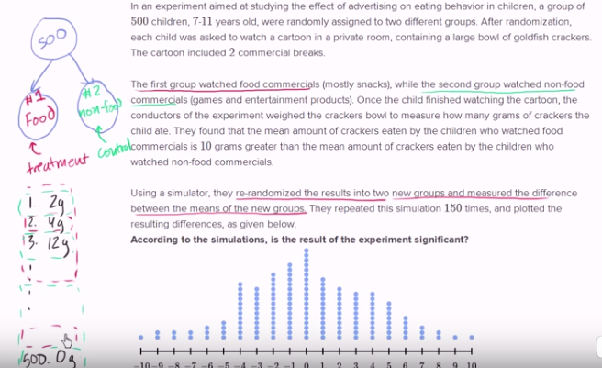
https://www.khanacademy.org/math/statistics-probability/probability-library/randomness-probability-and-simulation/v/statistical-significance-experiment

Simulate re-randomization of experiment’s results
import numpy, math, random
from statistics import mean, pstdev
numpy.set_printoptions(precision=2, linewidth=150, suppress=True)

class Experiment():
ControlGroupMeanSeed = 5
TreatmentGroupMeanSeed = 10

def __init__(self, NumberOfParticipants=500):
assert NumberOfParticipants%2==0, "The number of participants must be even!"
self._NumberOfParticipants = NumberOfParticipants
self._muControlGroup = round(random.random()*self.ControlGroupMeanSeed, 2)
self._muDifference = round(random.random() * self.TreatmentGroupMeanSeed + self.ControlGroupMeanSeed, 2)
self._muTreatmentGroup = round(self._muControlGroup + self._muDifference, 2)
self._sigmaControlGroup = round(self._muControlGroup * random.random(), 2)
self._sigmaTreatmentGroup = round(self._muTreatmentGroup * random.random(), 2)
self._lParticipants = self._MakeParticipantsList()
self._lControlGroup, self._lTreatmentGroup = self._SplitIntoTwoGroups(self._lParticipants)
self._lMeanDifferencesAfterRerandomization = []
@property
def NumberOfParticipants(self): return self._NumberOfParticipants
@property
def ControlGroupMean(self): return self._muControlGroup
@property
def TreatmentGroupMean(self): return self._muTreatmentGroup
@property
def ControlGroupStd(self): return self._sigmaControlGroup
@property
def TreatmentGroupStd(self): return self._sigmaTreatmentGroup
@property
def GroupsMeanDifference(self): return self._muDifference
@GroupsMeanDifference.setter
def GroupsMeanDifference(self, arg):
assert type(arg) in (int, float), "The argument must be an int or float!"
self._muDifference = arg
self._muTreatmentGroup = round(self._muControlGroup + self._muDifference, 2)
self._sigmaControlGroup = round(self._muControlGroup * random.random(), 2)
self._sigmaTreatmentGroup = round(self._muTreatmentGroup * random.random(), 2)

def Describe(self, PrintWhat='pre-experiment summary'):
import re

if any(s in PrintWhat.lower() for s in ('group', 'sample', 'array')):
iHowMany = 10
print("\nControl Group:"); print(self._lControlGroup[:10], "..." if len(self._lControlGroup)>iHowMany else "")
print("\nTreatment Group:"); print(self._lTreatmentGroup[:10], "..." if len(self._lTreatmentGroup)>iHowMany else "");print()
return

sValuesNames = """\
NumberOfParticipants
ControlGroupMeanSeed
TreatmentGroupMeanSeed
ControlGroupMean
TreatmentGroupMean
GroupsMeanDifference
ControlGroupStd
TreatmentGroupStd"""
sValuesNames = re.sub(r"([a-z])([A-Z])", r"\1 \2", sValuesNames)
lValuesNames = sValuesNames.split("\n")

lValues = [
self._NumberOfParticipants,
self.ControlGroupMeanSeed,
self.TreatmentGroupMeanSeed,
self._muControlGroup,
self._muTreatmentGroup,
self._muDifference,
self._sigmaControlGroup,
self._sigmaTreatmentGroup]

sText = "".join(["{:<{padding}} {}\n".format(s,v,padding=max([len(s) for s in lValuesNames])) for s,v in zip(lValuesNames, lValues)])
bApresExperiement = any(d['eaten'] for d in self._lTreatmentGroup)
print("SUMMARY ({} the experiment):\n".format("after" if bApresExperiement else "before") + sText)

def _MakeParticipantsList(self):
return [{'id':i, 'group':None, 'eaten':0} for i in range(1, self._NumberOfParticipants+1)]

def _SplitIntoTwoGroups(self, lParticipants):
lControlGroup = sorted(random.sample(lParticipants, int(self._NumberOfParticipants/2)), key=lambda d: d['id'], reverse=False)
lTreatmentGroup = sorted((d for d in lParticipants if d not in lControlGroup), key=lambda d: d['id'], reverse=False)
for d in lControlGroup: d['group'] = 0 #control group
for d in lTreatmentGroup: d['group'] = 1 #treatment group
return (lControlGroup, lTreatmentGroup)

def ConductTheExperiment(self):
ndGramsEatenInControlGroup = numpy.random.randn(int(self._NumberOfParticipants/2)) * self._sigmaControlGroup + self._muControlGroup
ndGramsEatenInTreatmentGroup = numpy.random.randn(int(self._NumberOfParticipants/2)) * self._sigmaTreatmentGroup + self._muTreatmentGroup
for nd in (ndGramsEatenInControlGroup,ndGramsEatenInTreatmentGroup):
for i,v in enumerate(nd):
if v < 0: nd[i] = 0

nd = numpy.array([self._lControlGroup, self._lTreatmentGroup, ndGramsEatenInControlGroup,ndGramsEatenInTreatmentGroup]).reshape(2,2, int(self._NumberOfParticipants/2))
nd = numpy.swapaxes(nd, axis1=0, axis2=1)
ndObjectMatrix = numpy.array(nd, dtype=numpy.object)

for e in (0,1):
for i,d in enumerate(ndObjectMatrix[e][0]):
d['eaten'] = round(ndObjectMatrix[e][1][i], 2)

self._lControlGroup, self._lTreatmentGroup = ndObjectMatrix[0][0], ndObjectMatrix[1][0]

"""Assign the new (actual) values"""
lGramsEatenInControlGroup = [d['eaten'] for d in self._lControlGroup]
lGramsEatenInTreatmentGroup = [d['eaten'] for d in self._lTreatmentGroup]
self._muControlGroup = round(mean(lGramsEatenInControlGroup), 2)
self._muTreatmentGroup = round(mean(lGramsEatenInTreatmentGroup), 2)
self._muDifference = round(self._muTreatmentGroup - self._muControlGroup, 2)
self._sigmaControlGroup = round(pstdev(lGramsEatenInControlGroup), 2)
self._sigmaTreatmentGroup = round(pstdev(lGramsEatenInTreatmentGroup), 2)
return self._lControlGroup, self._lTreatmentGroup

def RerandomizeTheGroups(self, arg=150): #returns the mean of the differences (resulted from the re-randomization)
assert isinstance(arg, int), "The argument must be an int!"
def _RerandomizeTheGroups(self):
assert any(d['eaten'] for d in self._lTreatmentGroup), "Use this function only after you have initiated the experiment!"
nd = numpy.hstack([self._lControlGroup, self._lTreatmentGroup])
lPooledBackTogether = sorted(nd, key=lambda d: d['id'])
lPseudoControlGroup = random.sample(lPooledBackTogether, int(self._NumberOfParticipants/2))
lPseudoTreatmentGroup = [d for d in lPooledBackTogether if d not in lPseudoControlGroup]
fPseudoControlGroupMean = mean([d['eaten'] for d in lPseudoControlGroup])
fPseudoTreatmentGroupMean= mean([d['eaten'] for d in lPseudoTreatmentGroup])
fMeanDifference = round(fPseudoTreatmentGroupMean - fPseudoControlGroupMean, 2)
self._lMeanDifferencesAfterRerandomization.append(fMeanDifference)
return fMeanDifference
[_RerandomizeTheGroups(self) for _ in range(arg)]
return mean(self._lMeanDifferencesAfterRerandomization) #returns the mean of the differences (resulted from the re-randomization)

def MakeHistogram(self):
import matplotlib.pyplot; matplotlib.pyplot.style.use('ggplot')
sp = matplotlib.pyplot.subplots()[1]
sp.hist(self._lMeanDifferencesAfterRerandomization, bins=10)
i = math.ceil(abs(self.GroupsMeanDifference))
sp.set_xticks(range(-i, i+1, 1))
matplotlib.pyplot.show()

def main():
o = Experiment()
o.GroupsMeanDifference = 10
o.Describe()

o.ConductTheExperiment()

o.Describe()
o.Describe(PrintWhat='samples')

f = o.RerandomizeTheGroups()
print("The mean of the mean-differences after the rerandomization:", f)
print("The real mean difference resulted from the experiment:", o.GroupsMeanDifference)

o.MakeHistogram()

if __name__=="__main__":main()

Probability problem
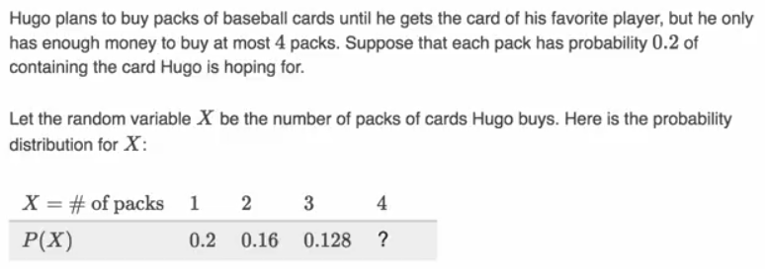

My code shows the probability Hugo finally buys a pack conaining the card he’s chasing on his nth purchase:
P = {}
P['contains a card'] = 0.2
P['does not contain a card'] = 1 - P['contains a card']

print("Probability you stop buying card packs on your nth purchase (because the pack you bought contains the card you're hunting for:")
P['total probability'] = 0
n = 0
while P['total probability'] <= 1:
P['current probability'] = P['does not contain a card']**n * P['contains a card']
P['total probability'] = P['total probability'] + P['current probability']
print(n+1, P['current probability'], P['total probability'])
n += 1
if n > 50:break

def Probability(fProbability): # yields a tuple: (nth purchase, current probability, cumulative probability)
i = 7
n = 0
fTotalProbability = 0
while True:
fCurrentProbability = (1-fProbability)**n * fProbability
fTotalProbability += fCurrentProbability
yield (n+1, round(fCurrentProbability, i), round(fTotalProbability, i))
n += 1

fProbability = 0.2
g = Probability(fProbability)

for e in g:
print(e)
if e[0] > 20: break

f = scipy.median(a)
f = scipy.mean(a)
f = scipy.var(a)
f = scipy.std(a)

Standard Deviation
biased unbiased (n-1)
f = numpy.std(a, ddof=0) f = numpy.std(a, ddof=1)
f = scipy.std(a, ddof=0) f = scipy.std(a, ddof=1)

dot product
f = scipy.dot(a,b)

def DotProduct(a, b): #is the same as: scipy.dot(a,b)
return sum(e1*e2 for e1,e2 in zip(a,b))
a and b are arrays

import scipy

a = [0,1,2]
b = [1,2,3]

f = scipy.dot(a,b)
print(f)

def DotProduct(a, b):
return sum(e1*e2 for e1,e2 in zip(a,b))

f = DotProduct(a, b)
print(f)

Covariance

Covariance
f = numpy.cov(a,b, bias=True)[0][1]

def Covariance(a,b):
n = len(a)
DeviationsFromTheMean = lambda arr : [e-(sum(arr)/n) for e in arr]
return scipy.dot(DeviationsFromTheMean(a), DeviationsFromTheMean(b)) / n

Covariance (unbiased)
f = numpy.cov(a,b)[0][1]

def CovarianceUniased(a,b):
n = len(a)
DeviationsFromTheMean = lambda arr : [e-(sum(arr)/n) for e in arr]
return scipy.dot(DeviationsFromTheMean(a), DeviationsFromTheMean(b)) / (n - 1)

Covariance (in a nutshell)
f = numpy.cov(a,b, bias=True)[0][1] biased
f = scipy.cov(a,b, bias=False)[0][1] unbiased

import scipy, numpy

a = [1,2,3,9]
b = [2,3,4,5]

f = numpy.cov(a,b, bias=True)[0][1]
print(f)

def Covariance(a,b):
DeviationsFromTheMean = lambda a : [e-(sum(a)/len(a)) for e in a]
n = len(a)
return scipy.dot(DeviationsFromTheMean(a), DeviationsFromTheMean(b)) / n

f = Covariance(a, b) ;print(f)

#############################################################################

f = numpy.cov(a,b)[0][1]
print(f)

def CovarianceUniased(a,b):
DeviationsFromTheMean = lambda a : [e-(sum(a)/len(a)) for e in a]
n = len(a)
return scipy.dot(DeviationsFromTheMean(a), DeviationsFromTheMean(b)) / (n - 1)

f = CovarianceUniased(a, b) ;print(f)

Correleation

Correlation
biased unbiased (n-1) (?)which one is biased ?
f = numpy.corrcoef(a, b, bias=True)[0,1] f = numpy.corrcoef(a, b, bias=False)[0][1]
f = scipy.corrcoef(a, b, bias=True)[0,1] f = scipy.corrcoef(a, b, bias=False)[0][1]
biased = good for the whole population unbiased = use for a sample

The correlation is unitless and always lies between -1 (perfect anti-correlation) and 1 (perfect correlation).

Correlation (unbiased i.e. n-1)
import scipy

a = [1,2,3,9]
b = [2,3,4,5]

f = scipy.corrcoef(a, b, bias=False)[0][1] ;print(f)

def CorrelationUnbiased(a,b):
aStd, bStd = (scipy.std(e, ddof=1) for e in (a,b))
if all(e>0 for e in (aStd, bStd)):
return scipy.cov(a,b, bias=False)[0][1] / aStd / bStd
else: return 0

f = CorrelationUnbiased(a, b) ;print(f)

statistics module
f = statistics.mean(a) f = scipy.mean(a)
f = statistics.median(a) f = scipy.median(a)
f = statistics.mode(a)

f = statistics.pvariance(a) f = numpy.var(a, ddof=0)
f = statistics.variance(a) f = scipy.var(a, ddof=1)

f = statistics.pstdev(a) f = numpy.std(a, ddof=0)
f = statistics.stdev(a) f = scipy.std(a, ddof=1)

Binomial distribution
"""What's the probability of scoring k goals in 6 attempts if the probability of scoring a goal is 70%?"""
from scipy.misc import comb as binom
P = lambda k : binom(6,k) * 0.7**k * 0.3**(6-k)

lBinomial = [P(k) for k in range(7)]
print(lBinomial)

"""Graph the binomial probability distribution"""
import matplotlib.pyplot as m

sp = m.subplots()[1]

sp.bar(range(7), lBinomial)

def E(k):
return 0.7 * 6

k = "random variable"
print("Expected value of this binomial distribution:", E(k))
sp.axvline(E(k), color='grey')

m.show()

Normal Distribution Curves
import matplotlib.pyplot as m
import math

def NormalPDF(x, mu=0, sigma=1):
return (math.exp(-(x-mu) ** 2 / 2 / sigma ** 2) / (math.sqrt(2 * math.pi) * sigma))

xs = [x / 10.0 for x in range(-50, 50)]

sp = m.subplots()[1]

sp.plot(xs,[NormalPDF(x,sigma=1) for x in xs],'-',label='mu=0,sigma=1')
sp.plot(xs,[NormalPDF(x,sigma=2) for x in xs],'--',label='mu=0,sigma=2')
sp.plot(xs,[NormalPDF(x,sigma=0.5) for x in xs],':',label='mu=0,sigma=0.5')
sp.plot(xs,[NormalPDF(x,mu=-1) for x in xs],'-.',label='mu=-1,sigma=1')
sp.legend()
m.title("Various Normal pdfs")
m.show()

kurtosis of a dataset
f = scipy.stats.kurtosis(a)

skewness of a dataset
f = scipy.stats.skew(a)

Central Limit Theorem
import numpy, math, random, scipy.stats, matplotlib.pyplot as m
from collections import Counter

iHowMany = 50

a = numpy.random.randint(low=1, high=iHowMany, size=iHowMany)
print(a[:10])

fVarEntireDataSet = numpy.var(a, ddof=0)

dc = Counter(a)
print({k:v for k,v in zip(tuple(dc.keys())[:10], tuple(dc.values())[:10])})

fig = m.figure("Central Limit Theorem", figsize=(6, 8))

sp = fig.add_subplot(4,1,1)
sp.bar(list(dc.keys()), list(dc.values()))
sp.axvline(numpy.mean(a), color='grey', linestyle='--')

a = list(a)
tSampleSizes = (3,10,15)
for iSampleSize in tSampleSizes:
l = []
[l.append(numpy.mean(random.sample(a, iSampleSize))) for _ in range(10000)]
sp = fig.add_subplot(4,1,2+tSampleSizes.index(iSampleSize))
dc = Counter(l)
X = list(dc.keys())
Y = list(dc.values())
sp.bar(X, Y)
sp.axvline(numpy.mean(l), color='grey', linestyle='--')
fKurtosis = round(scipy.stats.kurtosis(l), 2)
fSkewness = round(scipy.stats.skew(l), 2)
fStdTheoretical = math.sqrt(fVarEntireDataSet / iSampleSize)
fStdActual = numpy.std(l, ddof=0)
sp.axvline(numpy.mean(l)+fStdActual, color='grey', linestyle=':')
sp.axvline(numpy.mean(l)-fStdActual, color='grey', linestyle=':')
sText= "kurtosis: {}\nskewness: {}\ntheoretical std: {}\nactual std: {}\nmean: {}"\
.format(fKurtosis, fSkewness, round(fStdTheoretical,2), round(fStdActual,2), round(numpy.mean(l),2))
sp.text(0.05, 0.55, sText, transform=sp.transAxes, fontsize=8)
sp.set_xticks(range(0,iHowMany+1, 10))
m.show()

Permutations and Combinations

Permutation with Repetition
l = [chr(i) for i in range(ord("A"), ord("D")+1)]
g = ((e1,e2,e3) for e1 in l for e2 in l for e3 in l)
Example

i = 5 ** 3

Permutation without Repetition
g = itertools.permutations("ABCDE", 3)
n = 5 r = 3

i = math.factorial(n) // math.factorial(n - r)

Combination without Repetition
g = itertools.combinations("ABCDE", 3)

i = scipy.misc.comb(5, 3, repetition=False)

Combination with Repetition
g = itertools.combinations_with_replacement("ABCDE", 3)

i = scipy.misc.comb(5, 3, repetition=True)

demo
import itertools
from math import factorial as f
from scipy.misc import comb

"""Permutations with Repetition"""
i = 5 ** 3 ;print(i)
l = [chr(i) for i in range(ord("A"), ord("D")+1)]
g = ((e1,e2,e3) for e1 in l for e2 in l for e3 in l)
print(*g, sep="\n")

"""Permutations without Repetition"""
i = f(5) // f(5-3) ;print(i)
g = itertools.permutations("ABCDE", 3)
print(*g, sep="\n")

"""Combinations without Repetition"""
i = comb(5, 3, repetition=False) ;print(i)
g = itertools.combinations("ABCDE", 3)
print(*g, sep="\n")

"""Combinations with Repetition"""
i = comb(5, 3, repetition=True) ;print(i)
g = itertools.combinations_with_replacement("ABCDE", 3)
print(*g, sep="\n")

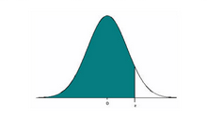
Z-Score

Calculate the z score of each value in the array, relative to the array mean and std
ndZscores = scipy.stats.zscore([1,2,3])

Get the z-score (i.e. distance from the mean menasured in std) from the area under the curve
fZscore = scipy.stats.norm.ppf(fAreaUnderTheCurve)

Area under the curve from the left end of the curve up to the given Z-Score
fAreaUnderTheCurve = scipy.stats.norm.cdf(fZscore)

from scipy.stats import norm
def ZScore(AreaUnderTheCurve): return norm.ppf(AreaUnderTheCurve)
def AreaUnderTheCurve(ZScore): return norm.cdf(ZScore)
function arguments:
AreaUnderTheCurve = area from the right end of the bell-curve
ZScore = distance from the mean (negative if going in the western direction)

pdf = probability density function
ppf = Percent point function
cdf = Cumulative Distribution Function

t-score, t distributions, student’s distribution

t_value = scipy.stats.t.ppf(0.95+0.05/2, df=30-1) #t-score for the middle 95% of the curve
area = scipy.stats.t.cdf(t_value, df=30-1) #total area under the curve from the lower end

R
t_value = qt(0.95+0.05/2, 29) #t-score for the middle 95% of the curve
area = pt(t_value, 29) #total area under the curve from the lower end

import scipy.stats
#Calculates the z score of each value in the sample, relative to the sample mean and standard deviation
ndZScores = scipy.stats.zscore([1,2,3])
print(ndZScores)

fAreaUnderTheCurve = 0.9783
Z_Score = scipy.stats.norm.ppf(fAreaUnderTheCurve)
print("How many Standard Deviations from the mean:", Z_Score)

#Calculate the area under the curve from the left up to the given Z-Score
Z_Score = 2.02
fAreaUnderTheCurve = scipy.stats.norm.cdf(Z_Score)
print("Area under the curve from the left end of the curve up to the given Z-Score:", fAreaUnderTheCurve)

A sampling distribution problem
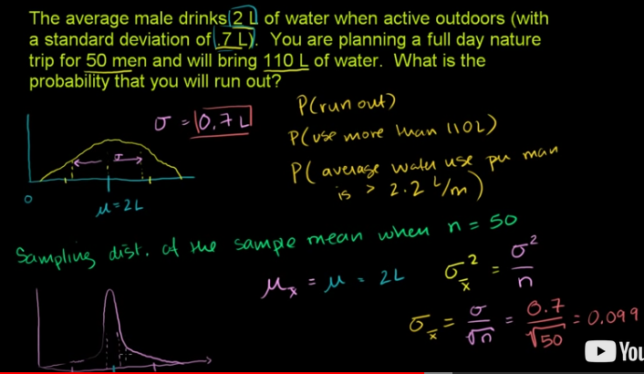

import numpy, math, scipy.stats

mu,sigma = 2, 0.7
iPeopleNumber = 50
fAmountOfWater = 110

"""Determine the probability theoretically"""
fStdOfMeansOfSamplesOf50 = sigma / math.sqrt(iPeopleNumber) # 0.09899
fAvgWaterConsumption = fAmountOfWater / iPeopleNumber # 2.2
fDistanceFromTheMean = fAvgWaterConsumption - mu # 0.2
fZscore = fDistanceFromTheMean / fStdOfMeansOfSamplesOf50 # 2.020
fAreaUnderTheCurveUpToTheZscore = scipy.stats.norm.cdf(fZscore) # 0.9783
fAreaUnderTheCurveFromTheZScoreToTheRight = 1 - fAreaUnderTheCurveUpToTheZscore
print("The probability is:", round(fAreaUnderTheCurveFromTheZScoreToTheRight, 4))

"""Determin the probability by simulation"""
k = 0
for i in range(0, 10001):
nd = numpy.random.randn(50) * sigma + mu
if numpy.sum(nd) > fAmountOfWater: k+=1
else: fProbability = k / i
print("Experimental probability:", fProbability)

https://www.khanacademy.org/math/statistics-probability/sampling-distributions-library/sample-means/v/sampling-distribution-example-problem

Hypothesis Testing
A single test has the probability of 99% of being accurate. What’s the probability that n out 100 tests are accurate?
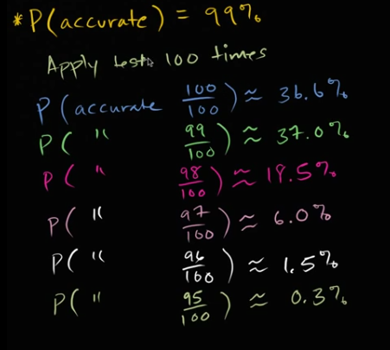
link: https://www.khanacademy.org/math/statistics-probability/significance-tests-one-sample/idea-of-significance-tests/v/idea-behind-hypothesis-testing

from collections import defaultdict
from re import findall
from scipy.misc import comb
import pandas, random

def P(s, p):
assert isinstance(s, str) and isinstance(p, float) and p <= 1 and p >= 0
v1,v2 = sorted(int(s) for s in findall(r"(\b\d+\b)", s))
return p**v1 * (1-p)**(v2-v1) * comb(v2,v1)
print("testing Theoretical Probability function: ", P('98 out of 100 are accurate', 0.99))

class RunTests():
def __init__(self, iHowManyTestsToRun, p):
self._iHowManyTestsToRun = iHowManyTestsToRun
self._p = p
d = {True:0, False:0}
for _ in range(iHowManyTestsToRun):
d[self._TestGaveAccurateResult()]+=1
self._iNumberOfAccurateResults = d[True]

@property
def NumberOfAccurateResults(self): return self._iNumberOfAccurateResults

def _TestGaveAccurateResult(self, p=None): #returns Boolean
if p is None: p=self._p
return False if random.random() >= p else True

def __str__(self): return "<{} out of {} tests are accurate>".format(self._iNumberOfAccurateResults, self._iHowManyTestsToRun)
o = RunTests(100, 0.5)
print("testing the RunTests class: ", o, o.NumberOfAccurateResults, "\n")
###################################################################################################################################

def main():
"""Theoretical proof"""
print("The probability that n tests out of 100 are accurate given that the probability that a single test is actually accurate is 99%")
p = 0.99 #probability that a single test is actually correct is 99%
srTheoretical = pandas.Series()
for i in range(100,94,-1):
f = P('{} out of 100 are accurate'.format(i), p)
srTheoretical.loc[i] = round(f,3)
s = "if n={:<3} the probability is {:>5,.1%}".format(i, f)
print(s)
#print(srTheoretical)

"""Experimental proof"""
iHowManyTestBatches = 1000
iHowManyTestsPerBatch = 100
fProbabilityOfASingleTestBeingAccurate = 0.99 #probability that a single test is actually correct is 99%

d = defaultdict(int)
for _ in range(iHowManyTestBatches):
d[RunTests(iHowManyTestsPerBatch, fProbabilityOfASingleTestBeingAccurate).NumberOfAccurateResults] += 1
print("\n", d, "\n\n")

"""Create a table with the experiment results"""
sr = pandas.Series(d)
sr.index.name="Number of accurate results"
sr.sort_index(ascending=False, inplace=True)
df = sr.to_frame()
df['Experimental Probability'] = sr / iHowManyTestBatches
df.drop(axis=1, labels=[0], inplace=True)
df['Theoretical Probability'] = srTheoretical
print(df)

if __name__=="__main__":main()

Mean and Std
mu = nd.mean()
sigma = nd.std(ddof=0)

„Standardize“ the distribution of the values in a certain column
Subtract the mean and divide by the standard deviation

sr = df['ColumnA']
sr = (sr - sr.mean()) / sr.std(ddof=0)
df['ColumnA'] = sr

from numpy import array
nd = array([10,20,30,40,50], dtype='i')

ndNew = (nd - nd.mean()) / nd.std(ddof=0)
print(ndNew) #correct

ndNew = nd / nd.std(ddof=0) - nd.mean()
print(ndNew) #wrong

‘Standardize’ the distribution in columns for cluster plot
import pandas, matplotlib.pyplot
import scipy.cluster.hierarchy

l_d = [{'band':'Iron Maiden', 'genre':"hard'n'heavy", 'albums_sold':20e+06}, #01e+06 = one million
{'band':'Deep Purple', 'genre':"hard'n'heavy", 'albums_sold':50e+06},
{'band':'Genesis', 'genre':"art rock", 'albums_sold':15e+06},
{'band':'Yes', 'genre':"art rock", 'albums_sold':12e+06},
{'band':'Depeche Mode', 'genre':'new wave', 'albums_sold':45e+06},
{'band':'Duran Duran', 'genre':'new wave', 'albums_sold':10e+06},
{'band':'Led Zeppelin', 'genre':"hard'n'heavy", 'albums_sold':70e+06}]

df = pandas.DataFrame(l_d)
print(df)

#####################################################################

df.set_index('band', drop=True, inplace=True)
df['albums_sold'] = pandas.to_numeric(df['albums_sold'], downcast='signed')

df['genre'] = df['genre'].astype('category')
df['genre'].cat.categories = [1,2,3]
df['genre'] = df['genre'].astype('int')
print(df)

#######################################################################

def StandardizeTheDistribution(sr):
assert isinstance(sr, pandas.Series), "The argument must be a pandas Series and not {}".format(type(sr))
return (sr - sr.mean()) / sr.std(ddof=0) #returns a Series

t = (df['genre'], df['albums_sold'])
for i,sr in enumerate(t):
#t[i].loc[:] = StandardizeTheDistribution(t[i])
sr[:] = StandardizeTheDistribution(sr) #same as above
#both of these lines cause a Warning from pandas
print(df)

WeightedScalar = 2 #if not for this line, the clustered plot would be incorrect
df['genre'] *= WeightedScalar #the 'weight' tells the cluster algorithm to consider this particlur field more important

##############################################################################

"""Create a plot"""
fig = matplotlib.pyplot.figure("Cluster Analysis")
sp = fig.add_subplot(1,1,1)

nd2D = scipy.cluster.hierarchy.linkage(df, method='ward') ;print(nd2D[:10])
d = scipy.cluster.hierarchy.dendrogram(nd2D, labels = df.index, leaf_font_size = 5)

"""Change the fontsize of the x labels"""
[e.set_fontsize(8) for e in sp.get_xticklabels()]
sp.set_ylabel('distance')
matplotlib.pyplot.show()

Mean difference of two arrays
import numpy

a1 = numpy.arange(10, dtype='i')
a2 = a1*2+2
print(a1, a2)

a1Mean = a1.mean()
a2Mean = a2.mean()
print(a1Mean, a2Mean)

MeanDifference = a1Mean - a2Mean
print(MeanDifference)

a = a1 - a2
MeanDifference = a.mean()
print(MeanDifference) #equals the above mean

Density function line, KDE
import matplotlib.pyplot as mp
import numpy, pandas, scipy.stats

nd = numpy.random.normal(0, 1, size=1000)
sp = mp.subplots()[1]

#scipy.stats.gaussian_kde
n,X,_ = sp.hist(nd, bins=numpy.linspace(-3, 3, 50), histtype='step', normed=True)
funcDensity = scipy.stats.gaussian_kde(nd)
sp.plot(X, funcDensity(X))

#pandas vizualization
sr = pandas.Series(nd)
sr.plot(kind="kde", ax=sp, linestyle="--")

mp.show()

Correlation coefficient

f = scipy.stats.linregress(X, Y).rvalue

Correlation coefficient is the sum of products of Z-scores (of each x and y data point) divided by the number of data points (minus one)

Correlation coefficient r
#Correlation coefficient r is the sum of products of Z-scores (of each x and y data point) divided by the number of data points (minus one)
import numpy, matplotlib.pyplot

"""Make a data set"""
iMax = 5
nd = numpy.random.randint(1,iMax+1, size=(2,4))
print(nd)

st = set(tuple(nd) for nd in nd.T)
print(st)
if len(st)<nd.shape[1]: print("Try again");exit()

##############################################################################
"""Calculate the Correlation coefficient r"""

xMean, yMean = (numpy.mean(nd) for nd in nd)
xStd, yStd = (numpy.std(nd) for nd in nd)
print('means:', xMean, yMean)
print("STD's:", xStd, yStd)

r = ((nd[0]-xMean)/xStd * (nd[1]-yMean)/yStd).sum() / (nd.shape[1]-0) #n-1 (?)
print("my correlation coefficient r:", r)

######################################################################
"""Verify your calculations"""
from scipy.stats import linregress
t = linregress(*nd) ;print(t);print("scipy.statslinregress(*nd).rvalue:", t.rvalue)
f = numpy.corrcoef(*nd, bias=False)[0,1] ;print("numpy.corrcoef(*nd, bias=False)[0,1]:", f)

import pandas
df = pandas.DataFrame(nd, index=[*"xy"])
f = df.loc['x'].corr(df.loc['y'])
print("df.loc['x'].corr(df.loc['y']):", f)

#########################################################################################
"""Make a plot"""
sp = matplotlib.pyplot.subplots()[1]
sp.plot(*nd, 'o')

sp.set_title(r"$r =\sum{(\frac{x_i-\bar{x}}{s_x})(\frac{y_i-\bar{y}}{s_y})} * \frac{1}{n-1}$")
sp.set_xticks(range(iMax+2)); sp.set_yticks(range(iMax+2))
sp.text(.5, 5.5, "correlation coefficient r = {}".format(linregress(*nd).rvalue))
matplotlib.pyplot.show()

Coefficient of determination
f = scipy.stats.linregress(X, Y).rvalue**2 #r-squared

Covariance

Covariance (of two random variables) is the difference between
the mean of products of two random variables (e.g. X and Y) and
the product of the means of these two random variables.
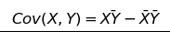

The covariance of a random variable (against itself) is its variance:
Var(X) = Cov(X,X)

The slope of the regression line is covariance devided by the variance of random variable X: $m=\frac{Cov\left(X,Y\right)}{Var\left(X\right)}$

import numpy, matplotlib.pyplot, pandas

"""Make a data set"""
iMax = 5
nd = numpy.random.randint(1,iMax+1, size=(2,4))
if len(set(tuple(nd) for nd in nd.T))<nd.shape[1]: print("Try again");exit()
else: print(nd)

##############################################################################
"""Calculate the covariance"""
f = (nd[0]*nd[1]).mean() - nd[0].mean() * nd[1].mean()
print("my covariance:", f)

######################################################################
"""Verify your calculations"""
f = numpy.cov(*nd, ddof=0)[0,1] ;print("n-0:", f)
f = numpy.cov(*nd)[0,1] ;print("Normalized by n-1 (unbiased estimator):", f)
df = pandas.DataFrame(nd)
f = df.iloc[0].cov(df.iloc[1]) ;print("Normalized by n-1 (unbiased estimator):", f)

#########################################################################################
"""Make a plot"""
sp = matplotlib.pyplot.subplots()[1]
sp.plot(*nd, 'o')

sp.set_title(r"$Cov(X,Y) = \bar{XY} - \bar{X}\bar{Y}$")
sp.set_xticks(range(iMax+2)); sp.set_yticks(range(iMax+2))
sp.text(.5, 5.5, "Cov(X,Y) = {}".format(round(f,2)))
matplotlib.pyplot.show()

Correlation, covariance, variance (biased)
f = numpy.corrcoef(a1,a2, bias=True)[0,1]

f = numpy.cov(a1,a2, ddof=0)[0,1]

f = numpy.var(nd[0], ddof=0)

import numpy, matplotlib.pyplot, pandas

"""Make a data set"""
iMax = 5
nd = numpy.random.randint(1,iMax+1, size=(2,4))
if len(set(tuple(nd) for nd in nd.T))<nd.shape[1]: print("Try again");exit()
else: print(nd)

##############################################################################
"""Calculate the slope"""
Cov = numpy.cov(*nd, ddof=0)[0,1] ;print("covariance:", Cov)
Var = numpy.var(nd[0], ddof=0) ;print("variance:", Var)
m = Cov / Var ;print("slope:", m)

######################################################################
"""Verify your calculations"""
from scipy.stats import linregress
f = linregress(*nd).slope ;print("slope:", f)

#########################################################################################
"""Covariance of a random variable against itself"""
Cov = numpy.cov(nd[0], nd[0], ddof=0)[0,1] ;print("covariance of X:", Cov)
b = Cov==Var ;print(b)

DataPointCounts, BinBreaks = sp.hist(nd, bins=10)[:-1]
len(BinBreaks) == len(DataPointCounts)+1

import numpy, matplotlib.pyplot

nd = numpy.random.normal(0,1, size=10)
print(nd)

sp = matplotlib.pyplot.subplots()[1]
DataPointCounts, BinBreaks = sp.hist(nd, bins=10)[:-1]

print(DataPointCounts)
print(BinBreaks)
print(len(DataPointCounts), len(BinBreaks))
matplotlib.pyplot.show()

QQ Plot = normal probability plot

Normalize the data points from a normal distribution
nd = (numpy.array(l) - fMean) / fStd

Normality Test with a QQ Plot
#http://www.statisticshowto.com/q-q-plots/
import numpy, matplotlib.pyplot
from statistics import mean, pstdev as std
numpy.set_printoptions(linewidth=160, suppress=True)

l = [3.77, 4.25, 4.5, 5.19, 5.89, 5.79, 6.31, 6.79, 7.19] #try this one
l = list(numpy.random.normal(5, 1.5, 20)) #or this one

l.sort()
iDataPoints = len(l)
fMean = mean(l) ;print(fMean)
fStd = std(l) ;print(fStd)

print()
################################################################

from scipy.stats import norm
def ZScore(AreaUnderTheCurve): return norm.ppf(AreaUnderTheCurve)
def AreaUnderTheCurve(ZScore): return norm.cdf(ZScore)

iNumberOfQuantiles = iDataPoints + 1
fAreaOfEachQuantile = 100 / iNumberOfQuantiles #in percent
lQuantilesCumulativeAreas = [i*fAreaOfEachQuantile/100 for i in range(1, iNumberOfQuantiles+1)] #in decimal percent
print(lQuantilesCumulativeAreas)
del lQuantilesCumulativeAreas[-1]

zScores = [ZScore(f) for f in lQuantilesCumulativeAreas]
print(zScores)

#########################################################
from scipy.stats import zscore
nd = (numpy.array(l) - fMean) / fStd
a = zscore(nd)
print(a)
f = numpy.corrcoef(a, zScores)[0,1]
print("correlation coefficient:", f) #is close to 1 meaning high correlation
##########################################################

sp = matplotlib.pyplot.subplots()[1]
lLine = sp.plot(zScores,l, 'go')

yIntercept = fMean
mSlope = fStd
X = lLine[0].get_xdata()
Y = X * mSlope + yIntercept
sp.plot(X,Y)

sp.grid(True)
matplotlib.pyplot.show()

Correlation (yet another summary)

import matplotlib.pyplot as mp
import numpy, pandas, scipy, scipy.stats

f = 3.0; n = 10

a1 = range(n)
a2 = numpy.arange(n) + f*numpy.random.randn(n)

mp.scatter(a1,a2) ;mp.show()

f = numpy.corrcoef(a1, a2, bias=True)[0,1]
f = scipy.corrcoef(a1, a2, bias=True)[0,1] #same
print(f)

f = scipy.stats.linregress(a1,a2).rvalue
print(f)

f = pandas.Series(a1).corr(pandas.Series(a2))
print(f)

f = numpy.corrcoef(a1, a2, bias=True)[0,1]
f = scipy.corrcoef(a1, a2, bias=True)[0,1]
f = scipy.stats.linregress(a1,a2).rvalue
f = pandas.Series(a1).corr(pandas.Series(a2))

import matplotlib.pyplot as mp
import numpy, pandas
pandas.options.display.width =160
pandas.options.display.precision = 3

n = 10
df = pandas.DataFrame(columns=range(n))

for _ in range(5):
df = df.append(pandas.Series(numpy.arange(n) + numpy.random.randint(low=0,high=5)*numpy.random.randn(n)), ignore_index=True)
else: df.index = [*"ABCDE"]; df=df.T; print(df)

df = df.corr(method='pearson')
print(df)

from itertools import permutations
import numpy

a1 = (1,2,3)
a2 = (4,5,6)
i = len(a1)

st = set()
for vc1 in permutations(a1, i):
for vc2 in permutations(a2, i):
n = (numpy.array(vc1) * numpy.array(vc2)).sum()
st.add(n)
print(n, vc1, vc2)
print(st)

Bootstrap (simulation)
import numpy, matplotlib.pyplot as mp
numpy.set_printoptions(precision=4, suppress=True)

tDataSample = (20,25,23,19,22,26,22,24,9)

l = []

for _ in range(1000):
nd = numpy.random.choice(tDataSample, size=100)
l.append(nd.mean())
print(l[:10])

sp = mp.subplots()[1]
sp.hist(l, bins=50)
mp.title("SD = {}".format(round(numpy.std(l),4)))
mp.show()

Standard Error
import random, statistics, math
import matplotlib.pyplot as mp

#all trees in the population
tDataSet1 = tuple(round(random.gauss(mu=10, sigma=2.5), 2) for _ in range(10000)) #oaks
tDataSet2 = tuple(round(random.gauss(mu=7, sigma=1.5), 2) for _ in range(20000)) #maples
tDataSet3 = tuple(round(random.gauss(mu=5, sigma=0.5), 2) for _ in range(15000)) #pine

#our data samples - measurements
n = 10 #10 measurements were performed for each tree type
print("Dataset samples:")
tDataSample1 = tuple(random.sample(tDataSet1, n)) ;print(tDataSample1)
tDataSample2 = tuple(random.sample(tDataSet2, n)) ;print(tDataSample2)
tDataSample3 = tuple(random.sample(tDataSet3, n)) ;print(tDataSample3)

print("\nsample means:")
Mean1 = statistics.mean(tDataSample1) ;print(Mean1)
Mean2 = statistics.mean(tDataSample2) ;print(Mean2)
Mean3 = statistics.mean(tDataSample3) ;print(Mean3)

print("\nsample standard deviations:")
Std1 = statistics.stdev(tDataSample1) ;print(Std1)
Std2 = statistics.stdev(tDataSample2) ;print(Std2)
Std3 = statistics.stdev(tDataSample3) ;print(Std3)

print("\nsample standard error:")
SE1 = Std1 / math.sqrt(n) ;print(SE1)
SE2 = Std2 / math.sqrt(n) ;print(SE2)
SE3 = Std3 / math.sqrt(n) ;print(SE3)

sp = mp.subplots()[1]
sp.bar((1,2,3), (Mean1,Mean2,Mean3), yerr=[SE1,SE2,SE3])
sp.set_xticks([1,2,3])
sp.set_xticklabels(['oak','maple','pine'])
sp.set_ylabel("height in meters")
mp.show()

random sampling vs 1 in k systematic sampling
import random, matplotlib.pyplot as mp
from statistics import mean

k = 0
for _ in range (1000):
t = tuple(round(random.gauss(mu=150, sigma=10),2) for _ in range(1000))

lRandomSampling = random.sample(t, 100) #random sampling
lSystematicSampling = t[100::100] #1 in k systematic sampling

MeanOfPopulation = mean(t) #;print("true mean:", MeanOfPopulation)
MeanRandomSampling = mean(lRandomSampling) #;print("mean of the random sample:", MeanRandomSampling)
MeanSystematicSampling = mean(lSystematicSampling) #;print("mean of 1 in k systematic sampling:", MeanSystematicSampling)

b = abs(MeanRandomSampling - MeanOfPopulation) < abs(MeanSystematicSampling - MeanOfPopulation)
#print("mean of random sampling is more accurate:", b)
if b: k+=1
else: print(k/1000) #if the result > 0.5 then mean of random sampling is more accurate than mean of 1 in k systematic sampling

_,nd = mp.subplots(3,1)
nd[0].hist(t, bins=100)
nd[1].hist(lRandomSampling, bins=10)
nd[2].hist(lSystematicSampling, bins=10)
mp.show()
looks like random sampling works better that 1 in k systematic sampling in Python

Comparative bar chart

When constructing a comparative bar chart, use relative frequency rather than frequency to construct the scale on the vertical axis so that meaningful comparisons can be made even if the sample sizes are not the same.

"""response to the question “Ideally how far from home would you like the college you attend to be?"""
s = """\
Frequency relative Frequency
Ideal distance Students Parents Students Parents
less than 250 miles 4450 1594 .35 .53
250 to 500 miles 3942 902 .31 .30
500 to 1000 miles 2416 331 .19 .11
More than 1000 miles 1907 180 .15 .06
"""
import pandas, matplotlib.pyplot as mp; from io import StringIO; from MyUtilities import print

df = pandas.read_table(StringIO(s), sep=r" [ ]+", skiprows=2, header=None, engine='python').set_index(keys=0, drop=True, inplace=False)
df.index.name="Ideal distance"
df.columns = pandas.MultiIndex.from_arrays([("Frequency", "Frequency", "Relative Frequency", "Relative Frequency"),("Students", "Parents", "Students", "Parents")])
print(df)
###############################################
df['Frequency'].plot(kind='bar', title="wrong barchart", rot=20, fontsize='x-small')
df['Relative Frequency'].plot(kind='bar', title="correct barchart - use realtive frequancy!", rot=20, fontsize='x-small')
mp.show()

Quantile, Percentile

sr = df.quantile(q=0.5, axis=1) the quantile is given as a float [0,1)
nd = numpy.percentile(nd, q=50, axis=1) the percentile is given as integer [0,100]

sr = df.quantile(q=0.25, axis=1, numeric_only=True, interpolation='linear')
nd = numpy.percentile(nd, q=50, axis=1, interpolation='linear')

f = numpy.percentile(nd, 50) the percentile is given as integer [0,100]

Quartiles, IQR, outliers

Outlier: An observation that is more than 1.5(iqr) away from the nearest quartile (the nearest end of the box)

Q1 = numpy.percentile(a, q=25)
Q1 = pandas.Series(a).quantile(q=0.25)

Q2 = median(a)
Q2 = numpy.percentile(a, q=50)
Q2 = pandas.Series(a).quantile(q=0.5)

Q3 = numpy.percentile(a, q=75)
Q3 = pandas.Series(a).quantile(q=0.75)

IQR = scipy.stats.iqr(a) IQR = scipy.stats.iqr(a, interpolation='nearest')

fThreshholdForLowerOutliers = Q1 - IQR * 1.5
fThreshholdForUpperOutliers = Q3 + IQR * 1.5

from statistics import median, mean
import scipy.stats, numpy, pandas, matplotlib.pyplot as mp

a = (1,2,3,4,5,6,7,12) #replace 12 with 11.5 and look at the boxplot

xbar = mean(a) ;print(xbar) #5
Q2 = median(a) ;print(Q2) #4.5
Q2 = numpy.percentile(a, q=50) ;print(Q2) #same
Q2 = pandas.Series(a).quantile(q=0.5) ;print(Q2) #same

Q1 = numpy.percentile(a, q=25) ;print(Q1) #2.75 and not 2.5 idky
Q1 = pandas.Series(a).quantile(q=0.25) ;print(Q1) #same

Q3 = numpy.percentile(a, q=75) ;print(Q3) #6.25 and not 6.5 idky
Q3 = pandas.Series(a).quantile(q=0.75) ;print(Q3) #same

ct = pandas.qcut(a, 4) ;print(ct)

MyQ1 = mean([2,3]) ;print(MyQ1) #2.5
MyQ3 = mean([6,7]) ;print(MyQ3) #6.5

IQR = scipy.stats.iqr(a) ;print(IQR) #3.5
MyIQR = MyQ3 - MyQ1 ;print(MyIQR) #4

fThreshholdForLowerOutliers = Q1 - IQR * 1.5 ;print(fThreshholdForLowerOutliers) #-2.5

fThreshholdForUpperOutliers = Q3 + IQR * 1.5 ;print(fThreshholdForUpperOutliers) #11.5
fThreshholdForUpperOutliers = MyQ3 + MyIQR * 1.5 ;print(fThreshholdForUpperOutliers) #12.5

sp = mp.subplots()[1]
sp.boxplot(a)
mp.show()

Percentiles
Q1 = numpy.percentile(a, q=25, interpolation='linear') linear = default
Q1 = numpy.percentile(a, q=25, interpolation='nearest') theoretical according to the textbook

import numpy
a = (1,2,3,4,5,6,7,8,9,10)

Q2 = numpy.median(a) ;print(Q2) #5.5
Q2 = numpy.percentile(a, q=50, interpolation='linear') ;print(Q2) #5.5
Q2 = numpy.percentile(a, q=50, interpolation='nearest') ;print(Q2) #5

Q1 = numpy.percentile(a, q=25, interpolation='linear') ;print(Q1) #3.25
Q1 = numpy.percentile(a, q=25, interpolation='nearest') ;print(Q1) #3

Q3 = numpy.percentile(a, q=75, interpolation='linear') ;print(Q3) #7.75
Q3 = numpy.percentile(a, q=75, interpolation='nearest') ;print(Q3) # 8

Quantiles = containers with equal number of data points in them but with different spans
Bins = containers with equal spans but filled with different number of data points

My Calulation of the r correlation coefficient
from scipy.stats import linregress
import scipy.stats
from statistics import mean, median, pstdev as std
from numpy import allclose

X = [1,2,3,4,5]; Y = [1,2,2,3,3]

t = linregress(X, Y)
print(t)

nd = scipy.stats.zscore(X)
print(nd)

def MyZScore(v, Mean=0, SD=1): return (v - Mean) / SD

l = [MyZScore(v, mean(X), std(X)) for v in X]
print(l)

ab = nd==l ;print(ab)
b = allclose(nd, l, rtol=0.0001) ;print(b)

ndXZScores = scipy.stats.zscore(X)
ndYZScores = scipy.stats.zscore(Y)

f = (ndXZScores * ndYZScores).sum() / len(X)
print(f)

b = f == t.rvalue ;print(b)
b = allclose(f, t.rvalue, rtol=0.001) ;print(b)

Residual plot
import numpy, matplotlib.pyplot as mp
from scipy.stats import linregress

fg,nd = mp.subplots(2,1); sp1,sp2 = nd

X = [1,2,3,4,5,6,7]
Y = numpy.array(X)**2
sp1.plot(X,Y, 'k.')

t = linregress(X, Y) ;print(t) #rvalue=0.97735555485044179

#line formula: y = mx+k (m=slope, k=y-intercept)
FormulaForTheLine = lambda x : x*t.slope+t.intercept

#best fit regression line assuming we're dealing with linear ...
sp1.plot(numpy.array(X)[[0,-1]], [FormulaForTheLine(X[0]), FormulaForTheLine(X[-1])])

#get the residuals
YResiduals = [y - y_hat for y,y_hat in zip(Y,[FormulaForTheLine(e) for e in X])]

#Residual plot - shows non-linear movement
sp2.plot(X, YResiduals, 'k.')

#plot congigs
sp1.set_xlim([0,max(X)+3])
sp1.set_ylim([0,max(Y)+10])
sp1.grid(True);sp2.grid(True)
mp.show()

Binomial and Geometric Distributions
from MyUtilities import print
import numpy, pandas; pandas.options.display.float_format = '{:.5f}'.format

"""BINOMIAL DISTRIBUTION"""

"""n = number of trials p = probability of success in each trial"""
def MeanValueOfABinomialRandomVariable(n, p): # counterpart of ExpectedValue(X, p) below
return n*p

def StandardDeviationOfABinomialRandomVariable(n, p): # counterpart of StdOfRandomVariable(X, p)
return (n*p*(1-p))**0.5

"""Probability Distribution"""
def BinomialProbabilityDistribution(n, p, cumulative=False, Plot=False): # = Binomial Probability Distribution = BinomialProbabilityDistribution
from math import factorial as f
sr = pandas.Series(index=range(n))
for i in range(0, n+1):
sr[i] = (f(n) / ( f(i) * f(n-i) ) ) * p**i * (1-p)**(n-i)
sr.index.name = "random variable value"
sr.name = "random variable probability distribution"
if cumulative: sr = sr.cumsum()
if Plot:
import matplotlib.pyplot as mp
sr.plot.bar()
mp.show()
return sr

""""X = [values of the discreet random variable] p = [the respective probabilities]"""
def ExpectedValue(X, p): # Mean value of a discrete random variable = Expected Value = mean value of a random variable x
assert len(X)==len(p)
X,p = [numpy.array(e) for e in (X,p)]
return numpy.sum(X*p)

def StdOfRandomVariable(X, p): # X = [values of the discreet random variable] p = [the respective probabilities]
assert len(X)==len(p); X,p = [numpy.array(e) for e in (X,p)]
fMean = ExpectedValue(X,p)
return numpy.sqrt(numpy.sum((X - fMean)**2 * p))

"""GEOMETRIC DISTRIBUTION"""

def GeometricProbability(x, p):
return (1-p)**(x-1) * p

def GeometricProbabilityDistribution(n, p, cumulative=False):
sr = pandas.Series(index=range(1,n+1))
[sr.set_value(label=i, value=(1-p)**(i-1) * p) for i in range(1,n+1)]
sr.name = "geometric probability distribution"; sr.index.name = "trials until success"
if cumulative: sr = sr.cumsum()
return sr

def main():
sr = BinomialProbabilityDistribution(n=10, p=.5)
print(sr)

fMean = MeanValueOfABinomialRandomVariable(n=10, p=.5)
print(fMean)
fMean = ExpectedValue(X=sr.index, p=sr.values)
print(fMean) #same

fStd = StandardDeviationOfABinomialRandomVariable(n=10, p=.5)
print(fStd)
fStd = StdOfRandomVariable(X=sr.index, p=sr.values)
print(fStd) #same

if __name__=="__main__":main()

demo of correlation coefficient calculation based on permutations vector sum of products
import itertools, pandas
from scipy.stats import linregress
pandas.options.display.width = 150

df = pandas.DataFrame(columns=["Permutations", "Vector sum of products", "Permutation coeff", "Correlation coeff"])

for t1 in itertools.permutations([1,2,3]):
for t2 in itertools.permutations([4,5,6]):
df = df.append(pandas.Series(["{} {}".format(t1,t2), sum(e1*e2 for e1,e2 in zip(t1,t2)), 1, linregress(t1,t2).rvalue], index=df.columns), ignore_index=True)

fMax = df[df.columns[1]].max()
fMin = df[df.columns[1]].min()
f = 2 / (fMax-fMin)
func = lambda x : (x - fMin) * f - 1
df[df.columns[2]] = df[df.columns[1]].apply(func)

print(df)

my correlation coefficient function based on permutations vector sum of products
def MyCorrelationCoefficient(X, Y):
from scipy.stats import linregress
assert all(hasattr(e, "__iter__") for e in (X,Y)) and all( type(e) in (int,float) for sq in (X,Y) for e in list(sq) ), "Both arguments must be sequences!"
assert len(X)==len(Y), "Must be of equal lengths!"
fMax = sum( e1*e2 for e1,e2 in zip(sorted(X), sorted(Y)) )
fMin = sum( e1*e2 for e1,e2 in zip(sorted(X), sorted(Y, reverse=True)) )
fXYScore = sum( e1*e2 for e1,e2 in zip(X, Y) )
return (fXYScore - fMin) * ( 2 / (fMax-fMin)) - 1, linregress(X,Y).rvalue # my result vs correct correlation coefficient r

def main():
x = MyCorrelationCoefficient([1,2,3,3,6], [9,7,5,4,6])
print(x)

if __name__=="__main__":main()

standard deviation of p_hat’s calculated with the theoretical formula and experimentally for comparison
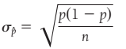
import numpy, random

nPopSize = 10000
p = random.random()

l = [1] * round(p*nPopSize) + [0] * round((1-p)*nPopSize)
random.shuffle(l)
print("N = {}".format(len(l)), "p = {}".format(p), sep="\n")

nUpperLimitForSampleSize = round(nPopSize * 0.1)
nLowerLimitForSampleSize = round(max( 10/p, 10/(1-p) ))

n = random.randint(nLowerLimitForSampleSize, nUpperLimitForSampleSize) #n = sample size
#n = 100
assert n*p >=10 and n*(1-p) >= 10, "Sample size must be large enough"
print("n = {}".format(n), "np = {:.1f} (must be >=10)".format(n*p), "n(1-p) = {:.1f} (must be >=10)".format(n*(1-p)), sep="\n")

sigma_p_hat = ((p*(1-p))/n) ** 0.5
print("standard deveation of p hat = {:.5f}".format(sigma_p_hat))

###################################

i = 1000 #number of samples taken (arbitrayr number)
lMeansOfSamples = []
for _ in range(i):
lCurrentSample = random.sample(l, n)
p_hat_of_the_current_sample = sum(lCurrentSample)/n
lMeansOfSamples.append(p_hat_of_the_current_sample)

print(lMeansOfSamples[:10])
print("mean of p hats = {:.3f}".format(numpy.mean(lMeansOfSamples)))

standard_deveation_of_the_p_hats = (((numpy.array(lMeansOfSamples) - numpy.mean(lMeansOfSamples))**2).sum() / len(lMeansOfSamples)) ** 0.5
print("standard deveation of p hats (df=0) = {:.5f}".format(standard_deveation_of_the_p_hats))
standard_deveation_of_the_p_hats = numpy.std(lMeansOfSamples, ddof=1)
print("standard deveation of p hats (df=1) = {:.5f}".format(standard_deveation_of_the_p_hats))

print("CONCUSION:\ntheoretical standard deveation ({:.3f}) is approximately equal to the experimental standard devation of p hats ({:.3f})".format(sigma_p_hat, standard_deveation_of_the_p_hats))

standard deviation of a sampling mean
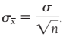
import random, statistics

N =10000
a = [random.gauss(mu=10, sigma=5) for _ in range(N)] #gaussian array
a = [random.randint(1,100) for _ in range(N)] #uniform distribution
print("standard deviation of the whole population:", statistics.pstdev(a))

n = 30 # n must be >= 30, otherwise use t distribution!
aSample = random.sample(a, n)

#According to the textbook formula
sigma_x_bar = statistics.pstdev(aSample) / n**0.5
print("theoretical standard deviation of the mean when n={} is:".format(n), sigma_x_bar)

#Experimentally
i = 1000 #how many samples to take
aSampleMeans = []
for _ in range(i):
aCurrentSample = random.sample(a, n)
fMeanOfTheCurrentSample = statistics.mean(aCurrentSample)
aSampleMeans.append(fMeanOfTheCurrentSample)

standard_deviation_of_the_means = statistics.stdev(aSampleMeans)
print("standard deviation of the means calculated experimentally:", standard_deviation_of_the_means)

#Histograms of the original array and the sampling means
import matplotlib.pyplot as mp
fg,[sp1,sp2] = mp.subplots(nrows=1, ncols=2, sharex=True, sharey=False)
sp1.hist(a)
sp2.hist(aSampleMeans)
mp.show()

Percentiles
import pandas, numpy
a = range(1,101)

#simple indexing - bugged
v5 = sorted(a)[round(0.05*len(a))]
v50 = sorted(a)[round(0.5*len(a))]
v95 = sorted(a)[round(0.95*len(a))]
print(v5,v50,v95)

#numpy
v5 = numpy.percentile(a, q=5, interpolation='linear')
v50 = numpy.percentile(a, q=50, interpolation='linear')
v95 = numpy.percentile(a, q=95, interpolation='linear')
print(v5,v50,v95)

#pandas
v5 = pandas.Series(a).quantile(0.05, interpolation='nearest')
v50 = pandas.Series(a).quantile(0.5, interpolation='nearest')
v95 = pandas.Series(a).quantile(0.95, interpolation='nearest')
print(v5,v50,v95)

Binomial distribution

exactly
p = scipy.stats.binom.pmf(k=3, n=5, p=0.3)
p = dbinom(3, 5, p=0.3) #R
=BINOM.DIST(3, 5, 0.3, FALSE) #Excel
probability that you’ll have exactly 3 sucesses out of 5 trials if the probability of each success is 0.3

at most
p = scipy.stats.binom.cdf(k=3, n=5, p=0.3)
p = pbinom(3, 5, p=0.3) #R
probability that you’ll have 3 or less sucesses out of 5 trials if the probability of each success is 0.3

at least
p = 1 - scipy.stats.binom.cdf(k=2, n=5, p=0.3)
p = 1 - pbinom(2, 5, p=0.3) #R
probability that you’ll have 3 or more sucesses out of 5 trials if the probability of each success is 0.3

chi squared
z = 8.18; k = 5
pvalue = 1 - scipy.stats.chi2.cdf(z, df=k-1) #python
pvalue = 1 - pchisq(z, df=k-1) #R

PROBABILITY

import random
aYears = ["2001","2002","2003"]

k = 0
iHowManySimulations = 10000
for iSumulation in range(1, iHowManySimulations+1):
if [random.choice(aYears) for _ in range(15)].count("2003") <= 3: k += 1

else: print("{} simulations run".format(iSumulation))
p = k / iSumulation # P(X<=3)
print("the probability of P(X<=3) = {:.1%}".format(p))

::UNSORTED::

Log
n = scipy.logn(2, 128)
n = math.log(128, 2)

import math
log = lambda b, y : math.log(y,b)
lg = math.log

x = log(10,100) ;print(x) #2
x = lg(100,10) ;print(x) #2

Sinusoid (for radians from 0 to pi/2)
import numpy, pandas, matplotlib.pyplot
numpy.set_printoptions(precision=4, linewidth=300)

a = numpy.arange(0, numpy.pi/2, 0.1)
print(a, len(a))

a = numpy.linspace(0, numpy.pi/2, 16)
print(a, len(a))

sr = pandas.Series(numpy.sin(a), index=a)
print(sr)

sp = matplotlib.pyplot.subplots()[1]
sp.plot(sr) #same as:
sr.plot()
sp.set_title("Sinusoid")
sp.text(0.1, 0.9, "$y=sin(x)$", transform=sp.transAxes)
matplotlib.pyplot.show()

Integer and Remainder
print(7 // 3, 7 % 3) # 2 1
# Debug.Print 7 \ 3, 7 Mod 3
# Debug.Print Int(7 / 3), 7 - Int(7 / 3) * 3
# =INT(7 / 3) =MOD(7, 2)

//Int\ %Mod

Integer – Whole number
i = n//d
i = int(n/d)
i = math.trunc(n/d)

Modulus
i = n%d
i = int((n/d - int(n/d))*d)

import math

n,d = 11,4
i = n//d ;print(i)
i = int(n/d) ;print(i) #same as above
i = math.trunc(n/d) ;print(i) #same as above

i = n%d ;print(i)
f = (n/d - int(n/d))*d ;print(f)

Trigonometric functions
import math

x = math.cos(0) ;print(x) #1
x = math.cos(math.pi) ;print(x) #-1
x = math.cos(math.pi*2) ;print(x) #1

x = math.asin(1) ;print(x, math.pi/2) #pi/2
x = math.acos(-1) ;print(x, math.pi) #pi
x = math.acos(0) ;print(x, math.pi/2) #pi/2

Euler’s number
import math

e = math.e #same as:
e = math.exp(1)
print(e)

if i % 3 == 0 reads “if i modulus 3 is equal to zero”

Trigonometry
f = math.radians(n) degrees to radians
n = math.degrees(f) radians to degrees

f = math.tan(math.radians(n)) get the tanganet of n degrees
n = math.degrees(math.atan(f)) get the degrees from the tan
sin and cos are calculated in an analogous manner

Degrees to radians graph
import math, numpy, pandas, matplotlib.pyplot

r = range(90)
sr = pandas.Series(r,r)
sr = sr.apply(math.radians)
print(sr)

sp = matplotlib.pyplot.subplots()[1]
sp.plot(sr)
sp.grid(True); sp.axis([0,90, 0,1.6]); sp.set_xlabel("degrees"); sp.set_ylabel("radians")
matplotlib.pyplot.show()
Linear correlation

nd = numpy.logspace(start=1, stop=10, num=10, endpoint=True, base=10, dtype=numpy.int)

import numpy
nd = numpy.logspace(start=1, stop=10, num=10, endpoint=True, base=10, dtype=numpy.int)
print(nd)

Complex numbers
x = 5+1j
y = 0-4j

z = x+y
print(z)

x = (1+4j)*(5+1j)
print(x)

Complex numbers
import numpy
from MyPrint import p as print

cx = 5+2j ;print(cx, 2)

print(numpy.array(dir(complex)))

f = cx.imag ;print(f)

f = cx.real ;print(f)

cxNew = cx + cx.conjugate() ;print(cxNew, 2)

cxNew = cx * cx.conjugate() ;print(cxNew, 2)

e raised to the power of e
f = math.exp(math.e)

My tangent plot
import matplotlib.pyplot, numpy
numpy.set_printoptions(suppress=True, precision=4)

iNumberOfDataPoints = 360

nd = numpy.zeros(iNumberOfDataPoints*3).reshape(3,iNumberOfDataPoints)

nd[0] = numpy.arange(0,iNumberOfDataPoints) #x values
nd[1] = nd[0]* (numpy.pi / 180) #x values in radians
nd[2] = numpy.tan(nd[1]) #y values

for i,v in enumerate(nd[0]):
if v%90==0:
for ii in range(len(nd)):
nd[ii][i] = numpy.nan

print(nd);print(nd[0][90])

matplotlib.pyplot.plot(nd[0], nd[2])
matplotlib.pyplot.axhline(0, color='k', alpha=0.5)
matplotlib.pyplot.axis([0,360,-50, 50])
matplotlib.pyplot.xticks(range(0,360,45))
matplotlib.pyplot.xlabel("degrees of an angle", fontsize=8)
matplotlib.pyplot.ylabel("slope aka tangent", fontsize=8)
matplotlib.pyplot.grid(True)
matplotlib.pyplot.title("Relationshsip of the angle of the slope line and its slope.")
matplotlib.pyplot.show()

Exploring the right triangle the alternative way
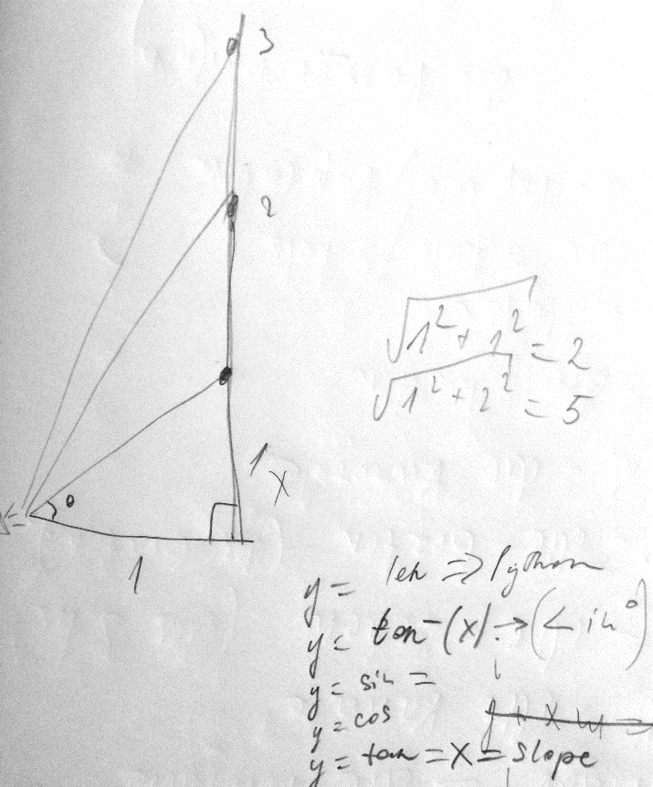
import numpy, matplotlib.pyplot
numpy.set_printoptions(linewidth=150)

iNumberOfDataPoints = 100
MaxValue = 10

sp = matplotlib.pyplot.subplots()[1]

a = numpy.linspace(0, MaxValue, iNumberOfDataPoints)
nd = numpy.zeros(len(a) * 5).reshape(5, len(a))
nd[0] = a

"""Length of the hypotenuse"""
nd[1] = [numpy.sqrt(1 + e**2) for e in nd[0]]
sp.plot(nd[0], nd[1], color="blue", label="length of the hypotenuse")

"""The angle in degrees"""
nd[2] = numpy.degrees(numpy.arctan(nd[0])) #in degrees
nd[3] = numpy.arctan(nd[0]) #in radians
sp.plot(nd[0], nd[2], color="red", label="angle in degrees")

"""The sine"""
nd[4] = numpy.sin(nd[3])
spTwin =sp.twinx()
spTwin.plot(nd[0], nd[4], color='green', label="sin")
spTwin.set_ylabel("sin", color="green")
spTwin.tick_params(axis='y', colors='green')

Exploring the sinusoid
$$y=a*\sin\left(p*x+h\right)+v$$

a = increases/decreases the amplitude
p = increases/decreases the period
h = moves the sinusoid horizontally
v = moves the sinusoid vertically

import numpy, matplotlib.pyplot, seaborn; numpy.set_printoptions(linewidth=150)

class C():
NumberOfPeriods = 2
NumberOfDataPoints = 300

sp = matplotlib.pyplot.subplots()[1]

"""Simple sinusoid"""
X = numpy.linspace(start=0, stop=2*numpy.pi*C.NumberOfPeriods, num=C.NumberOfDataPoints, dtype='f')
Y = numpy.sin(X)
sp.plot(X,Y, label="$y = sin(x)$")

"""linear increment of amplitude"""
YLinearIncrementOfAmplitude = (X/10+1) * numpy.sin(X)
sp.plot(X, YLinearIncrementOfAmplitude, label=r"linear increment of amplitude: $y = (\frac{x}{10}+1) * sin(x)$")

"""linear compression of period"""
YLinearIncrementOfPeriod = numpy.sin(X * (X/10+1))
sp.plot(X, YLinearIncrementOfPeriod, label = r"linear compression of period: $y = sin ( (\frac{x}{10}+1) * x )$")

"""combination of the two above"""
Y = (X/10+1) * numpy.sin(X * (X/10+1))
sp.plot(X, Y, color='grey', linestyle=":", label = "combination of the two above")

"""Configure the plot"""
sp.axhline(0, color='k', alpha=0.5)
sp.legend(fontsize=8)
matplotlib.pyplot.show()

v = None
f = math.nan
f = numpy.nan
b = math.nan == numpy.nan #False

f = math.pi
f = math.e
f = math.inf
f = -math.inf

The real and imaginary parts of a complex number
f = (2+3j).real
f = (2+3j).imag

i = math.ceil(f)
i = math.floor(f)

n choose k = combination without repetition
x = scipy.misc.comb(n,k)

combination with repetition
x = scipy.misc.comb(n,k, repetition=True)

The greatest common denominator
i = math.gcd(8, 52)

Prime Number Generator
def IsPrime(n): #1 is omitted
assert int(n)==n, "Whole numbers only, please!"
if n==1: return None
for i in range(2,n):
if n%i==0: return False
else: return True

def PrimeNumbersGenerator(n):
assert int(n)==n, "Whole numbers only, please!"
for i in range(2, n+1):
if IsPrime(i):
yield i

Calculating the mean when the array changes
from scipy import mean

l = [1,2,3,4,5]
fAvg = sum(l) / len(l)
print("The mean is", fAvg)

v = 3
l[-1] += 3 # one value in the list grows by a ceratin number
fNewAvg = fAvg + v / len(l) # this increment must be spread over all the slots in the array
print("The new mean is", fNewAvg, mean(l))

########################################

l = [1,2,3,4,5]
fAvg = sum(l) / len(l)
print("The mean is", fAvg)

v = 6
l.append(v)

fNewAvg = (fAvg * (len(l)-1) + v) / len(l)
print("The new mean is", fNewAvg, mean(l))

Solving Polinomial Equations

nd = numpy.roots([n,n,n]) n,n,n are the polynomial coefficients

import numpy
"""PROBLEM 1 - In what system is 7 represented as 111 ?
1x^2 + 1x^1 + 1x^0 = 7
x^2 + x + 1-7 = 0
x^2 + x + 6 = 0
The coefficients are: [1, 1, -6]
"""
nd = numpy.roots([1,1,-6])
print(nd) # The answer is 2

"""PROBLEM 2
The number 341 is written in an unknown system. We know that it equals 96 in base ten system.
In what system is 341 written?
3x^2 + 4x^1 + 1x^0 = 96
3x^2 + 4x + 1 - 96 = 0
3x^2 + 4x - 95 = 0
So the coefficients for our equation are: [3,4,-95]
"""
nd = numpy.roots([3,4,-95])
print(nd)
print("The answer is: base {}".format(int(nd[nd>0][0])))

import numpy
""" Find a root which is a positive whole number (if any) for the equation:
3x^2 + 4x + 1 = 96
3x^2 + 4x - 95 = 0
So the coefficients for the equation are: [3,4,-95]
"""
nd = numpy.roots([3,4,-95])
print(nd)

ndRes = numpy.logical_and(nd>0, nd%1==0)
print(ndRes)
n = nd[ numpy.logical_and(nd>0, nd%1==0) ][0]
print("The positive whole root of the equation is {}".format(int(n)))

Graph sin, cos, tan
from MyPrint import p as print, p2 as p2
import math, numpy, scipy, pandas, matplotlib.pyplot

r = range(1,90)
sr = pandas.Series(data=r, index=r)

sInput = input("Type: sin, cos or tan: ").lower().strip()
if sInput not in "sin cos tan".split(" "): raise ValueError("Wrong input")
s = "math.{}(math.radians(arg))".format(sInput)
sr = sr.map( lambda arg : round(eval(s), 4))
#sr = sr.map( lambda arg : round(math.tan(math.radians(arg)), 4))
print(sr, sr[45])

(fig,sp)=matplotlib.pyplot.subplots()
sp.plot(sr)
nOneSelectedPointOnTheGraph = 45 # =45 degrees
sp.plot([nOneSelectedPointOnTheGraph], sr[nOneSelectedPointOnTheGraph], "go") #one point on the graph
sp.grid(True)

n = 58 if sInput=="tan" else 1
r = range(0,n,2)
sp.set_yticks(r)
sp.set_yticklabels(labels=r, fontsize="xx-small")
sp.axis([0,90, 0,n])

matplotlib.pyplot.show()

Exploring the right triangle
(my code – may contain miscalculations or bug)
"""Exploring the right triangle.
Depict graphically the relationship between the length of the opposite side and:
1) the length of the hypotenuse
2) degrees of the angle (between the hypotenuse and the adjacent side)
3) tan
4) sin
5) cos"""
###################################################
import math, numpy, matplotlib.pyplot; from MyPrint import p as print, d as d; numpy.set_printoptions(precision=4, linewidth=170)
#####################################################
""" CONSTANTS """
a = 1 #the adjacent side is always 1 cm
fIncrementOfTheXAxis = 0.1
iMaxLengthOfTheOppositeSide = int(input("Enter the maximum length of the opposite side: "))
ndXValues = numpy.arange(0.1, iMaxLengthOfTheOppositeSide, fIncrementOfTheXAxis)
sp = matplotlib.pyplot.subplots()[1]
l = [] #l list of plot lines (to be used later for the legend)

"""THE HYPOTENUSE"""
ndHypotenuseLength = (ndXValues**2 + 1) ** (1/2)
l += sp.plot(ndXValues, ndHypotenuseLength)

"""DEGREES OF THE ANGLE """ ### degrees = tan^- (opposite/adjacent) ; adjacent=1
#NOTE: math.atan(x) returned in radian, if you want degree, convert it using math.degrees(x)
f1 = lambda x : math.degrees(math.atan(x))
f1 = numpy.vectorize(f1)
ndDegreesOfTheAngle = f1(ndXValues)
l += sp.plot(ndXValues, ndDegreesOfTheAngle)

"""TANGENT""" # tan = opposite/adjacent since a=1 tan=opposite tan=ndXValues
n = 10
l += sp.plot(ndXValues[::n], ndXValues[::n], "k.")
g = zip(ndXValues, ndHypotenuseLength) #tangent/opposite side length vs hypotenuse length
#print(*g)

"""SINE"""
ndSin = ndXValues / ndHypotenuseLength
spTwin = sp.twinx()
l += spTwin.plot(ndXValues, ndSin, "--y")
spTwin.set_ylabel("sin, cos", color="orange", rotation=0)

"""COSINE"""
ndCos = 1/ndHypotenuseLength
l += spTwin.plot(ndXValues, ndCos, ":g")

""" GRAPH SETTINGS """
sp.legend(l, ["length of the hypotenuse", "angle size in degrees", "tan", "sin (the right y-axis)", "cos (the right y-axis)"], fontsize="x-small", loc=0)
sp.axis([0,iMaxLengthOfTheOppositeSide, 0,90])
sp.set_xlabel("Length of the opposite side")
sp.grid(True)
#sp.set_xticks([1] + [*range(10,100,10)])

matplotlib.pyplot.show()

Solve systems of linear equations

nd = numpy.linalg.solve(aLeftSideOfTheEquationMatrix, aRightSideOfTheEquationMatrix)[0]
nd = numpy.linalg.lstsq(aLeftSideOfTheEquationMatrix, aRightSideOfTheEquationMatrix)[0]

import numpy.linalg
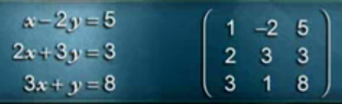
ndAnswer = numpy.linalg.solve([[3,1],
[1,2]], [9,8])
print(ndAnswer)

l = [[3, 1, 9],
[1, 2, 8]]

def SplitTheMatrix(a):
nd = numpy.array(a)
nd1 = nd[:, :-1]
nd2 = nd[:, -1]
return (nd1, nd2)

t = SplitTheMatrix(l)
print(t, "\n")

ndAnswer = numpy.linalg.solve(*t)
print("The solution is: x = {}, y={}".format(*ndAnswer))

###############################################

aLeftSideOfTheEquationMatrix = numpy.array([[1, -2],[2, 3], [3, 1]])
aRightSideOfTheEquationMatrix = numpy.array([5, 3, 8])

t = numpy.linalg.lstsq(aLeftSideOfTheEquationMatrix, aRightSideOfTheEquationMatrix)
nd = t[0]

print("The solution is: x = {}, y = {}\n".format(*nd) )
print(t)
for o in t: print(o)

SymPy

import sympy

x, y, z = sympy.symbols('x y z')

d = sympy.solve([x - 3], x) ;print(d)
d = sympy.solve((x + 5*y - 2, -3*x + 6*y - 15), x, y) ;print(d)
d = sympy.solve((x + 5*y - 2, -3*x + 6*y - 15), x, y, z) ;print(d)

d = sympy.solve([x-2*y-5, 2*x+3*y-3, 3*x+y-8], x, y) ;print(d)
d = {k.__str__():v for k,v in d.items()}
s = "The solution is x={x}, y={y}".format(**d)
print(s)

Total number of combinations
i = HowManyElements
TotalCombinations= sum(comb(n,k) for n in range(1, i+1) for k in range(1, n+1))

from scipy.misc import comb

m = 5
l = []
for n in range(1, m+1):
for k in range(1, n+1):
l.append(comb(n,k))
print("{}C{} = {}".format(n,k,l[-1]))
print(l, sum(l))

# same as above but more concise
nSum = sum(comb(n,k) for n in range(1, m+1) for k in range(1, n+1))
print(nSum)

t = divmod(11,3) #(3, 2)
i = 11 // 3 #3
i = 11 % 3 #2

import scipy.spatial
import numpy
from MyUtilities import print

p = (1,2,3)
q = (4,5,6)

f = scipy.spatial.distance.euclidean(p, q)
print(f, 2)

f = numpy.linalg.norm(numpy.array(p) - numpy.array(q))
print(f, 2)

#R
#p = c(1,2,3); q = c(4,5,6)
#f = dist(matrix(c(p,q), nrow=2, byrow = T))[1]

Eucledian distance between two points
p = (1,2,3); q = (4,5,6)
f = scipy.spatial.distance.euclidean(p, q)
f = numpy.linalg.norm(numpy.array(p) - numpy.array(q))

#R
p = c(1,2,3); q = c(4,5,6)
f = dist(matrix(c(p,q), nrow=2, byrow = T))[1]

Linear Algebra

Matrix multiplication (dot product)
nd = numpy.dot(nd, nd.T)

Inverse matrix
nd = numpy.linalg.inv(nd)

l = [[ 1, 4],
[-1,-3]]

nd = numpy.linalg.inv(l) #inverse matrix of the original matrix
nd = numpy.dot(l, nd) #if an identity matrix is returned then the original matrix
was not singular, meaning that the returned matrix is a true inverse matrix

import numpy; from MyUtilities import print
numpy.set_printoptions(suppress=True)

l = [[ 1, 4],
[-1,-3]]

nd = numpy.linalg.inv(l)
print(nd) #inverse matrix

nd = numpy.dot(l, nd)
print(nd) #identity matrix

#############################################

l = [[1,-1, 0],
[1, 0,-1],
[6,-2,-3]]

nd = numpy.linalg.inv(l)
print(nd) #inverse matrix

nd = numpy.dot(l, nd)
print(nd) #identity matrix

#################################################

l = [[1,2,3],
[4,5,6],
[7,8,9]]
nd = numpy.linalg.inv(l)
print(nd) #should throw 'Singular matrices don't have an inverse matrix' error

nd = numpy.dot(l, nd)
print(nd) #not an identity matrix - hence the original matrix is a singular matrix and doesn't have an inverse matrix

Matrix determinant
n = numpy.linalg.det(a)

If the determinant of a matrix is equal to zero, then that matrix is not invertable, aka singular matrix

import numpy; from MyUtilities import print
numpy.set_printoptions(suppress=True)

a = [[ 3,-1],
[-2, 2]]

n = numpy.linalg.det(a)
print(n)

a = [[2,1],
[4,2]]

n = numpy.linalg.det(a)
print(n) #0 meaning this matrix is not invertable

a = [[ 1, 4,-2],
[ 3, 2, 0],
[-1, 4, 3]]

n = numpy.linalg.det(a)
print(n)

some diagonal operations (with a matrix)
import numpy; from MyUtilities import print
numpy.set_printoptions(suppress=True)

nd = numpy.arange(1,10, dtype='d').reshape(3,3)
print(nd)

nd1D = numpy.diag(nd)
print(nd1D)

nd2D = numpy.diag(nd1D)
print(nd2D)

v = numpy.trace(nd)
print(v)

==UNSORTED==

Multidimensional (Linear) Regression in matrix form

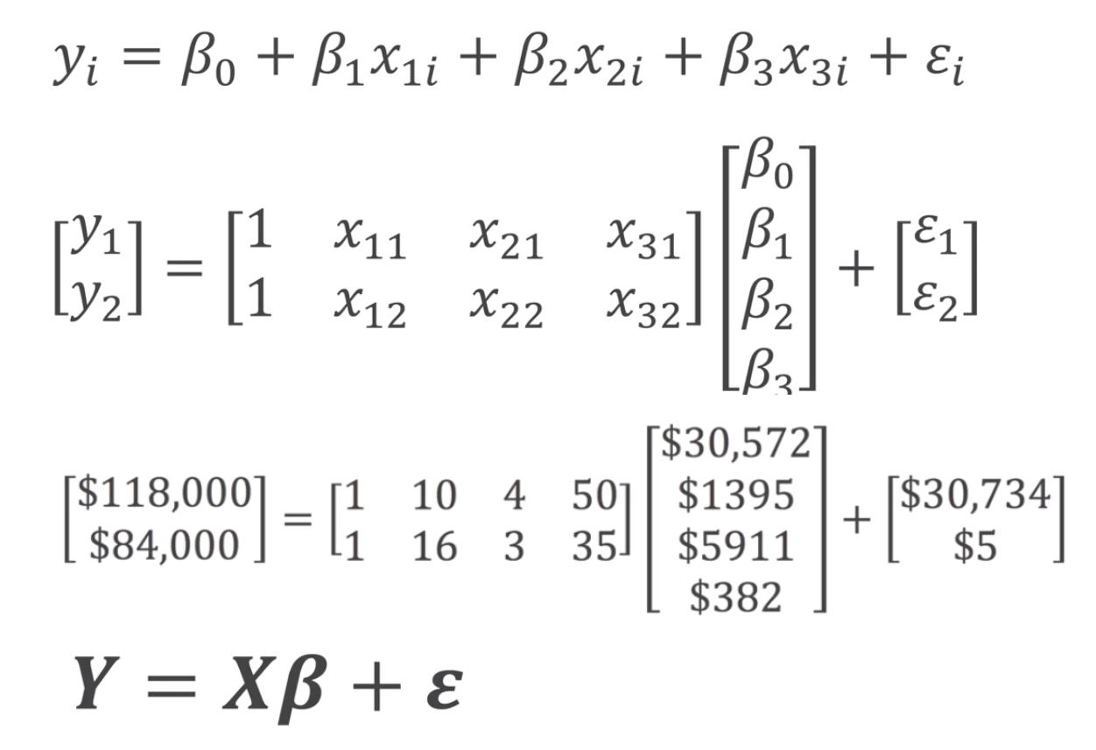

import numpy as np; from MyUtilities import print
X = np.matrix([[1,10,4,50],
[1,16,3,35]])
b = np.array([30572, 1395, 5911, 382]) #coefficients (vertical) vector
e = np.array([30734, 5]) #epsilon = errors = (vertical) vector
print(X, b, e)
Y = np.dot(X, b) + e
print(Y) #[118000 84000]
#=== predict === This is how md.predict() method works under the hood
X = np.matrix([[1, 7, 6, 55],
[1, 17, 2, 34],
[1, 12, 2, 46]])
Y = np.dot(X, b)
print(Y) #[96813 79097 76706]
#=== here is matrix multiplication ====
A = np.matrix([[1,10,4,50], [1,16,3,35]])
B = A.T
C = A * B # 2x4 x 4x2 = 2x2 mtrix
print(C) # result: 2x2 mtrix

matrix operations for multiple (linear) regression
X = rbind(c(1,10,4,50),
c(1,16,3,35)) # X = matrix
b = cbind(c(30572, 1395, 5911, 382)) # b = matrix (vertical) vector of coefficients
e = cbind(c(30734, 5)) # e = matrix = (vertical) vector of errors (epsilon)

Y = X %*% b + e
print(Y) # Y = matrix

#===predict===
X <- rbind(c(1, 7, 6, 55), c(1, 17, 2, 34), c(1, 12, 2, 46))
y <- X %*% b #predicted values
print(y)

#===soppose these are the real values===
yreal <- cbind(c(100000, 80000, 75000))
e <- yreal - y
print(e) #errors

